
Assignment 1
Data Visualization

June 9, 2023
justit
Atikur Rahaman

Table of Contents

Task 1 Policies and Procedures of working with data 2
Task 2 Excel GDP Tasks Set a password to protect the workbook 4
Highlight column C and change the data to display in British pound symbol. 11
Turn the GDP sheet into a table 13
Filter the table to display only the information for 2019 15
Create a chart that will only display 17
Add a title 19
Add X and Y axis labels 21
Make the chart visually pleasing. 23
Move the chart to new Sheet and label it a suitable name. 25
Create a sort for top 20 highest ranking countries. 25
New bar chart for top 20 countries 28
Colour the background by highlighting the area 29

MACRO TASK 30
Creating buttons 34
Using the copy macro, copy the sheet and then paste it into a new word document 42
Save your documents as ‘Word Gross domestic product report 1’ 44
Header and Footer for the table 45
TABLEAU 51
Set relationships 52
Tableau visual link 53

TASK - 1

Policies and Procedures of working with data
An organisation’s policies are at the heart of its business operations. They detail exactly how employees should handle certain issues, ensuring that everybody is on the same page and following agreed best practices.
Effective poli
cies are all the more important now that the GDPR (General Data Protection Regulation) is in place.
Five data security policies that all organisations must have.
1. Encryption policies
Most companies lack policies around data encryption. That will need to improve now as the GDPR is in effect, because one of its key tenets is that organisations should secure data with “appropriate technical and organisational measures”. Current guidance states that encryption is central to this.
Although encryption won’t stop malicious actors accessing an organisation’s information, it will prevent them from being able to use it.
It works by obscuring information and replacing identifiers with something else, meaning it is only accessible or understandable to approved users.
Organisations might also choose to pseudonymise data, either instead of or alongside encryption.

2. Acceptable use policies

If employees spend all day on non-work-related websites, there could be an acceptable use policy in place.
This outlines any activities that are outright prohibited, as well as stating limits on the amount of time employees can spend pursuing non-work activities.
Your acceptable use policy should also tell employees how the organisation monitors them to ensure the policy is being followed.
3. Password policies
There is so much advice on creating strong passwords, and so many warnings about the perils of weak ones, that there is simply no excuse for employees to use combinations such as “password1” or “0123456”.

Policies should outline guidance for what a password should look like (e.g. a combination of letters, numbers and special characters) and require staff to use different passwords for each account.

They should also implement systems that prompt staff to change their password at least every six months.

4. Email policies
IT should have a policy in place that hardens systems and detects spam and viruses. “The kind of information that can be disclosed via email should be spelt out very clearly,” said Rickard.

One of the biggest email-based threats is phishing, which can be mitigated by technology only to some extent.

Scam emails often look legitimate enough to bypass spam filters, meaning the only thing standing between an organisation and a data breach is the employee’s ability to recognise the threat.

Email policies should, therefore, mandate that employees take regular staff awareness courses to stay up to date with the threat of email-based fraud.

5. Data handling and processing policies
Organisations should map the way data flows through their organisation to see what data is being processed, how it’s being used and who is receiving it. So a policy is required to ensure this happens.

This has become especially important since the GDPR took effect, as it enables organisations to account for all their data and provide the necessary information to individuals who submit data subject access requests.
The core points of working with data are as follows.
- Allow the right people to access the data: Make sure the right people can access that data when and where they need it. Instead of issuing blanket rules for everyone in the company, it is often smart to set up different levels of permissions so each person can access the relevant data to do their jobs. It can be difficult to find the right balance between convenience and security, but if your team cannot access the data they need efficiently, it can lead to a loss of time and money.
- Prioritize data security: Data should be appropriately accessible within the organization, but data protections should be in place to keep customer’s data secure from outsiders. Team members need to be trained on how to handle data properly, and ensure your processes meet compliance requirements. Be prepared for the worst-case scenario and have a strategy in place for handling a potential breach. Finding the right data management software can help keep your data secure and safe.

TASK - 2
Excel
GDP Tasks
- Set a password to protect the workbook
- Select File > Info.
- Select the Protect Workbook box and choose Encrypt with Password.
- Enter a password in the Password box, and then select OK.
- Confirm the password in the Re-enter Password box, and then select OK.
- Finally save the workbooke
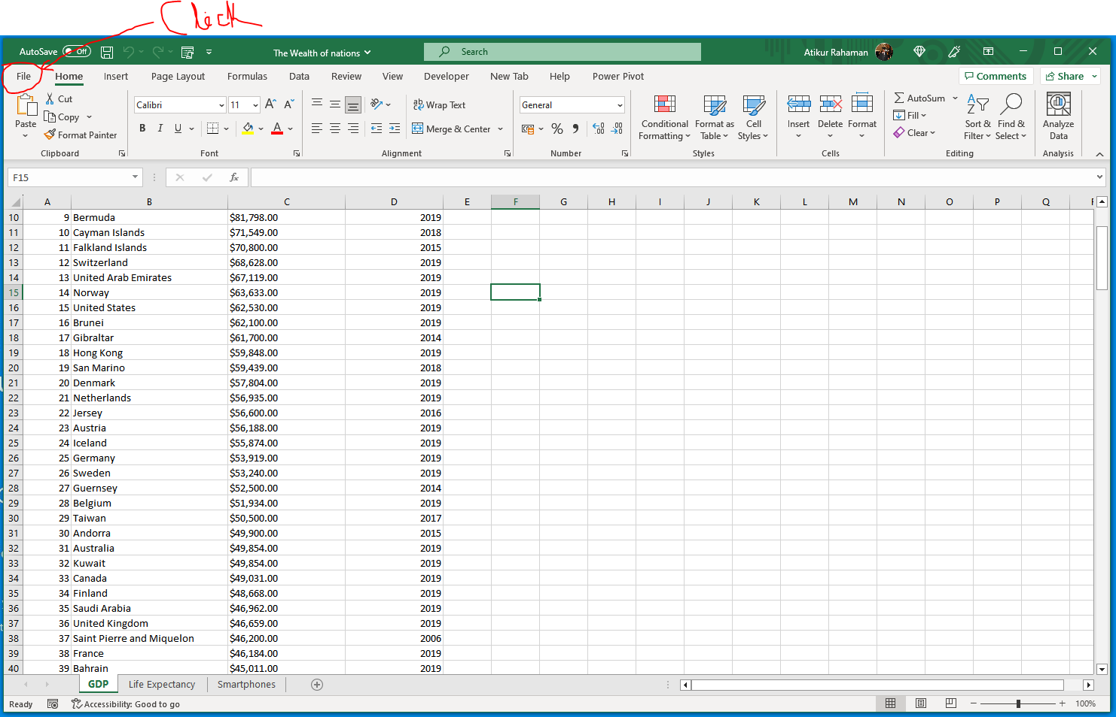
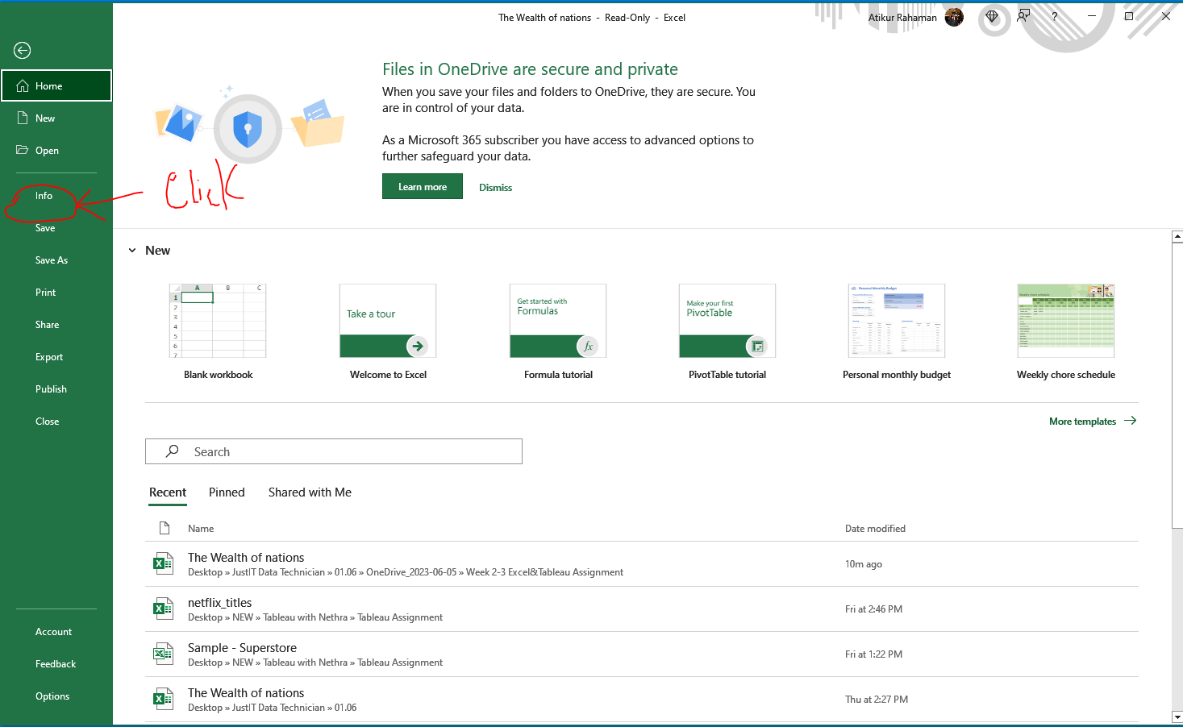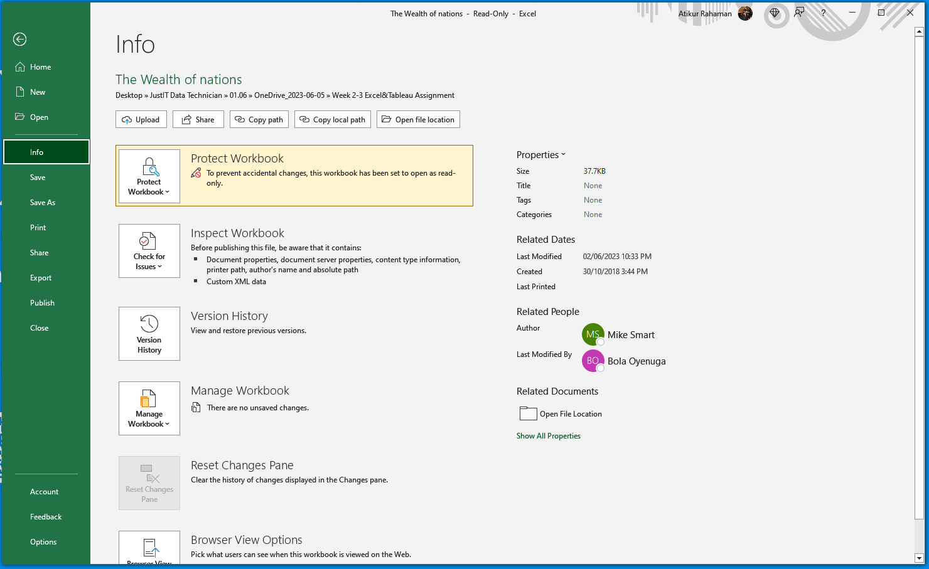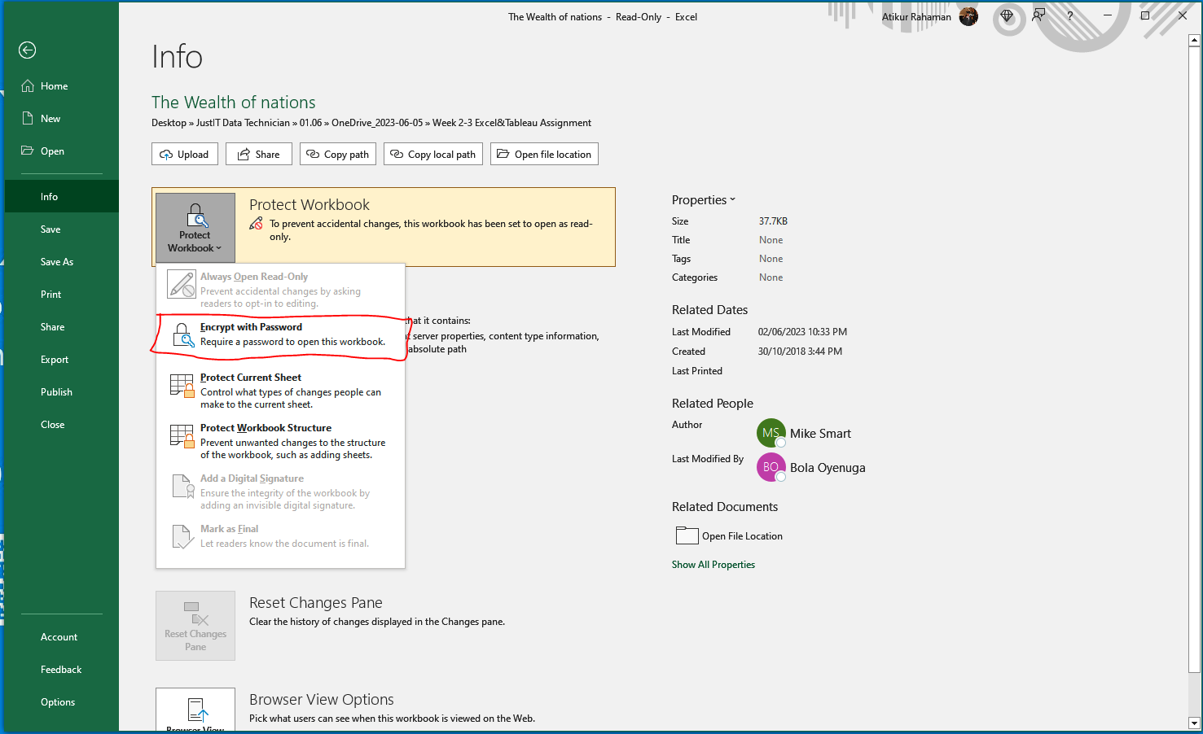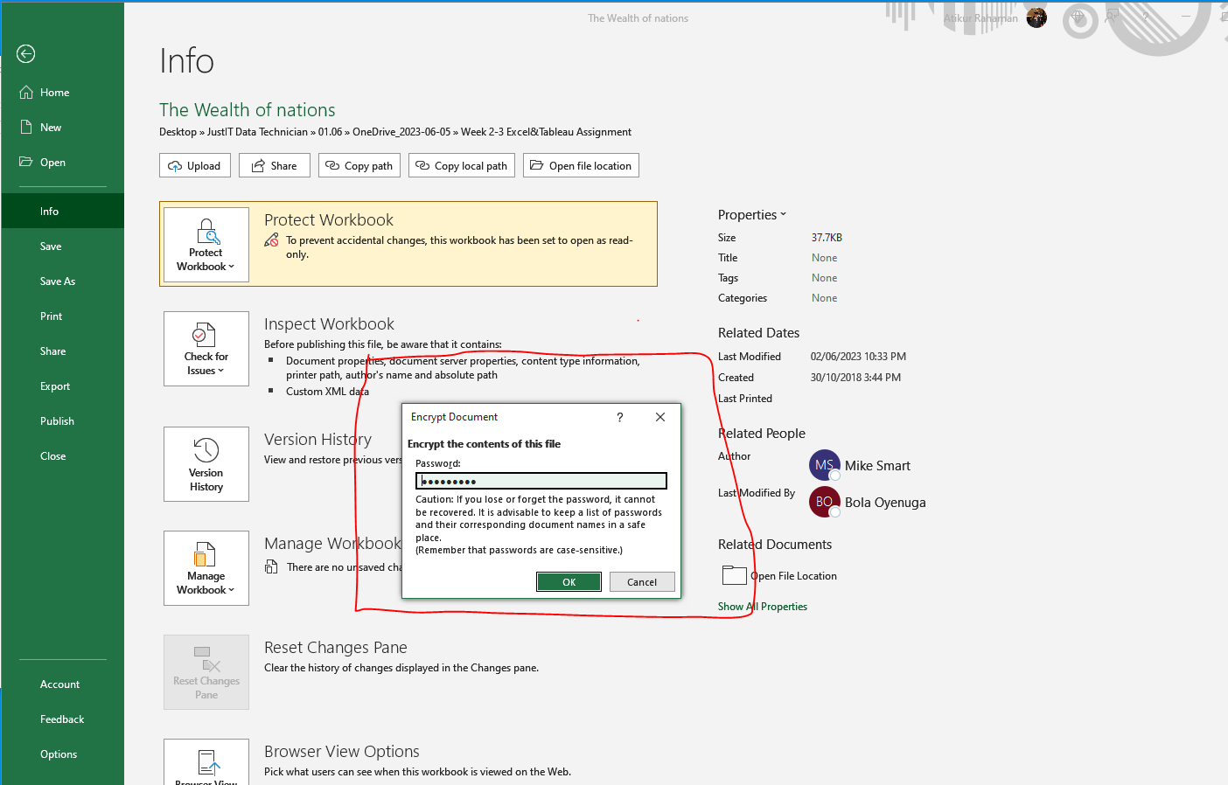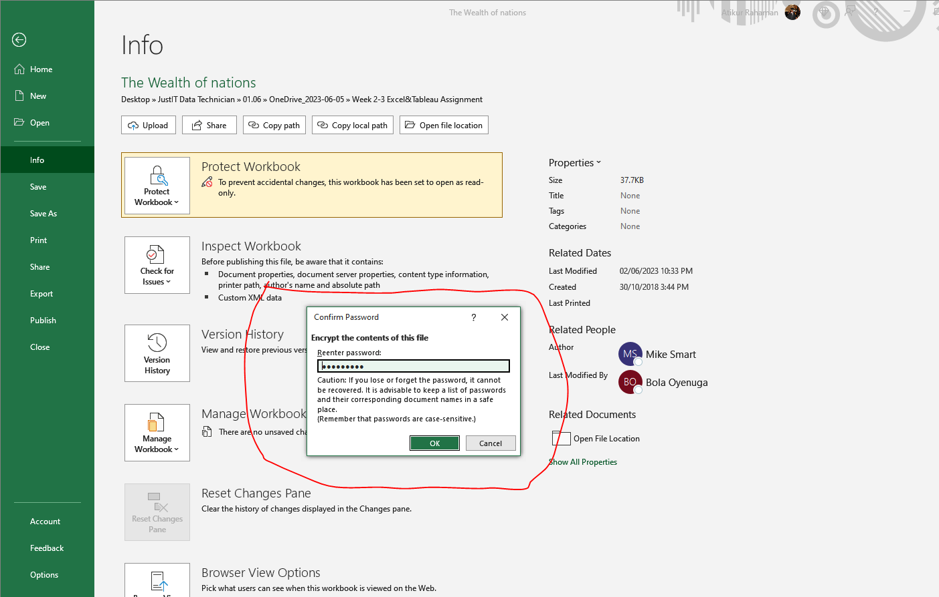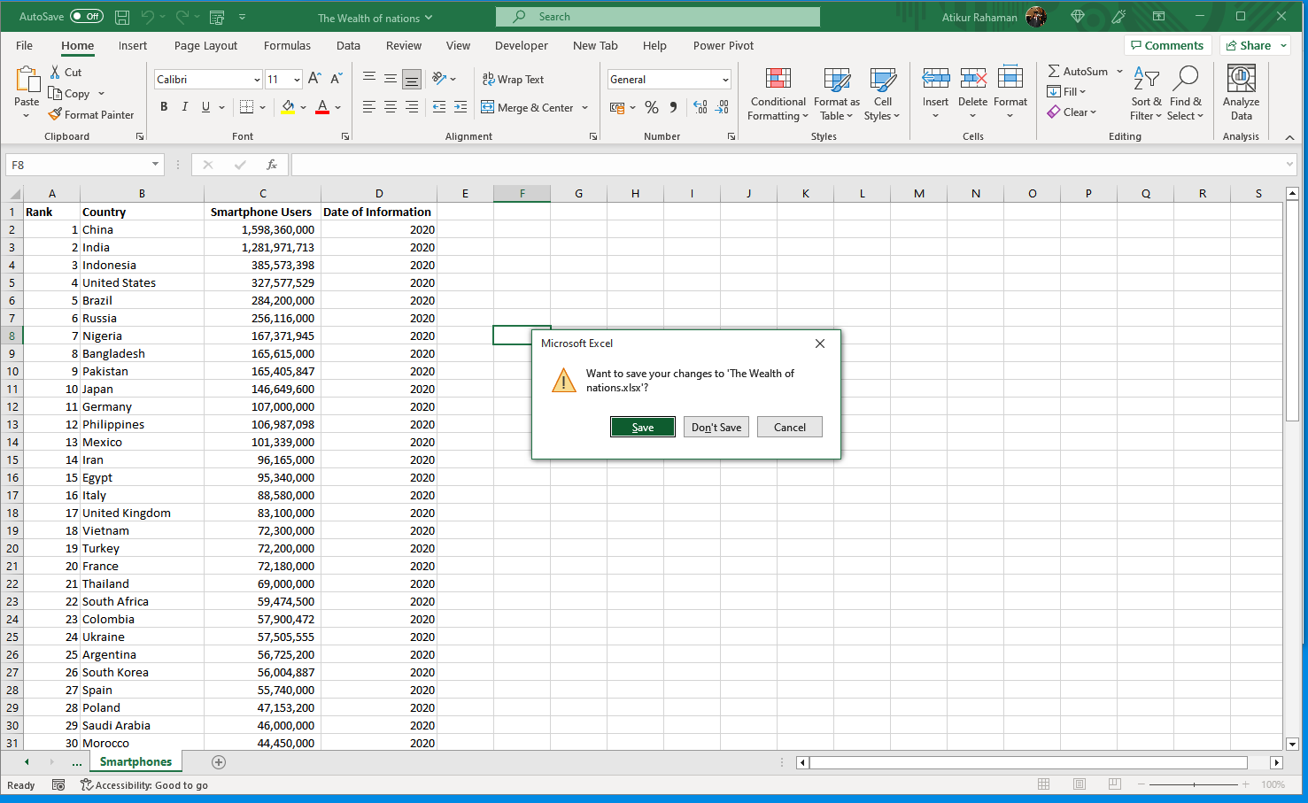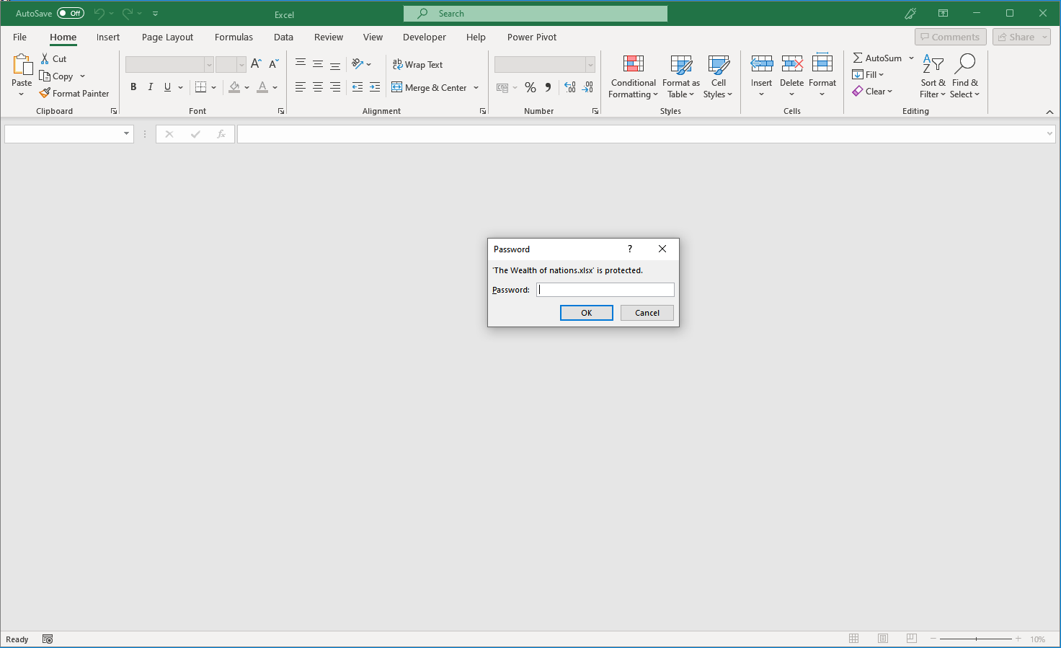

There is another way of doing it.

File> Save as> More option> Tools > General Options> from there Whatever requirement as per users
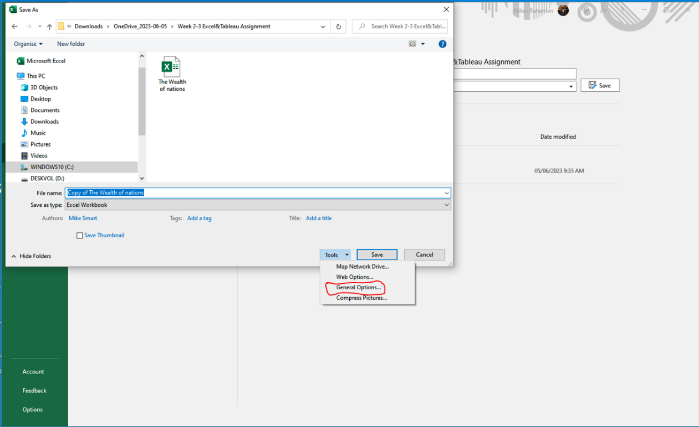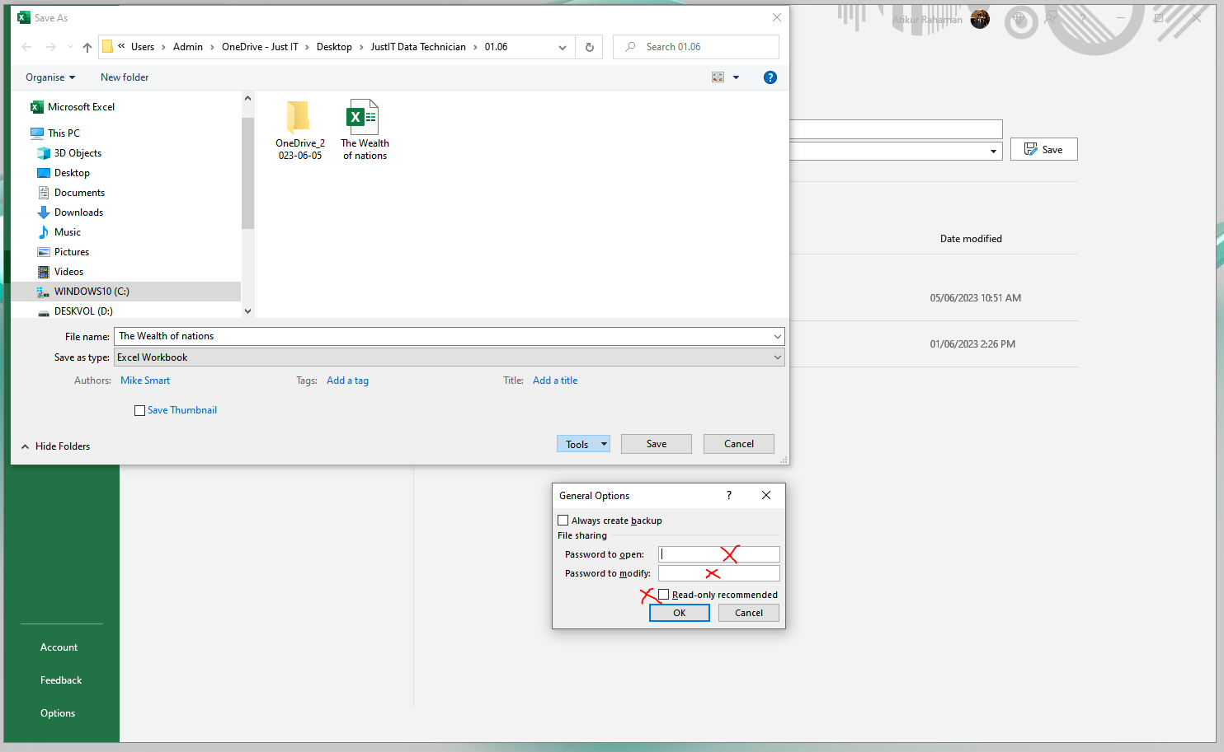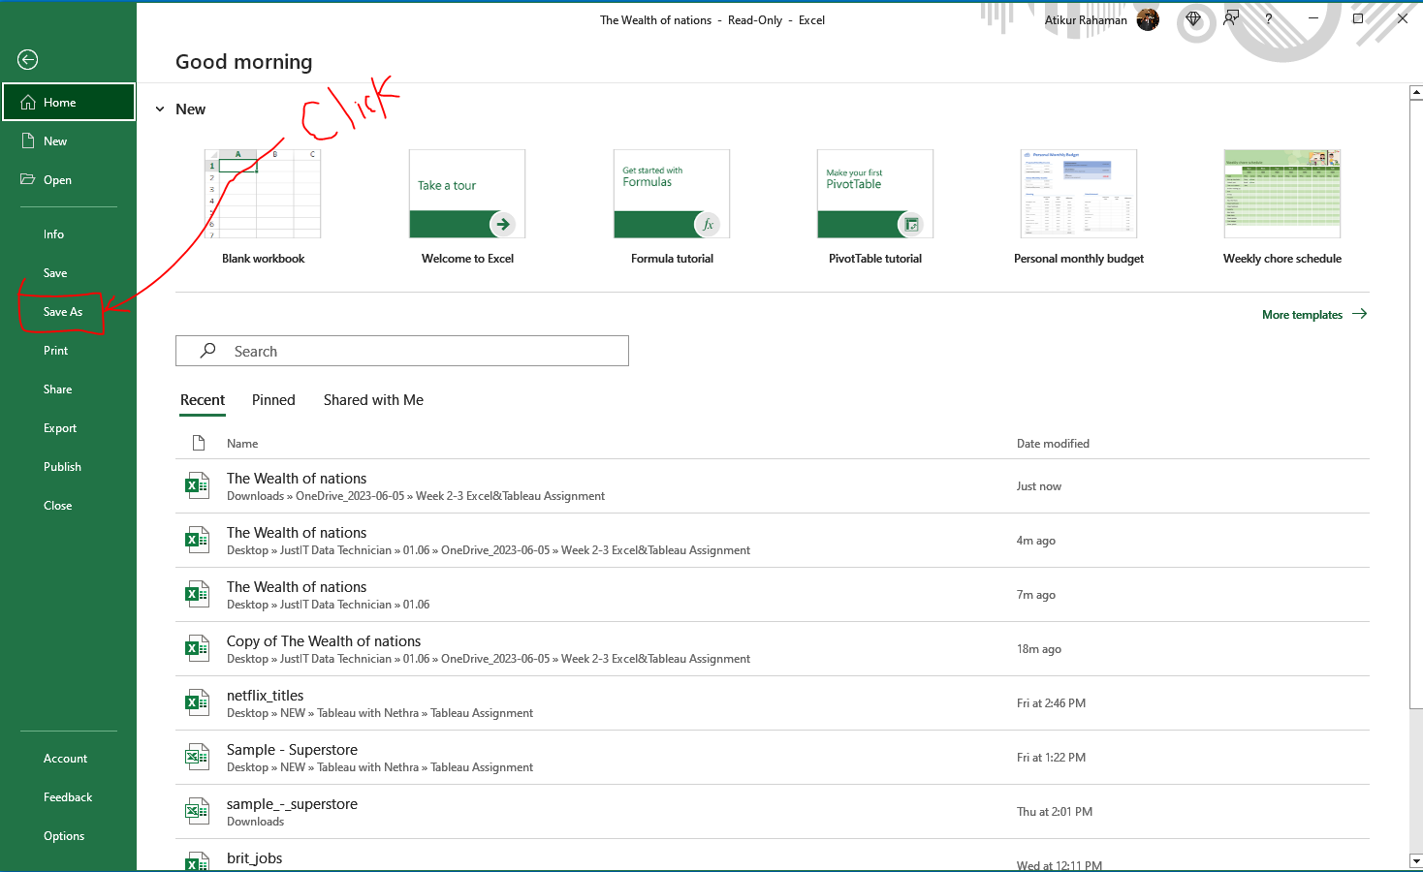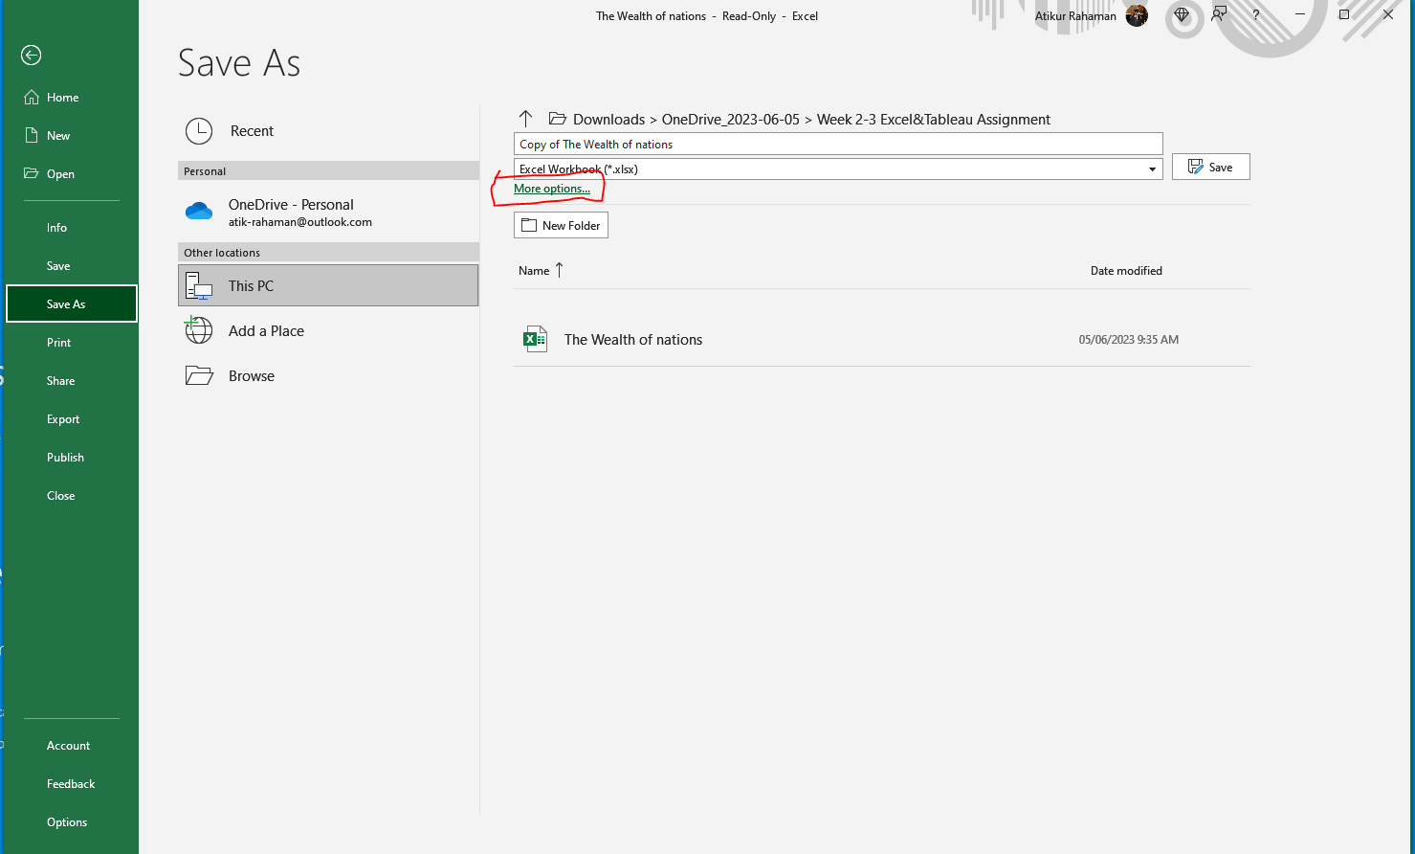

- Highlight column C and change the data to display in British pound symbol.
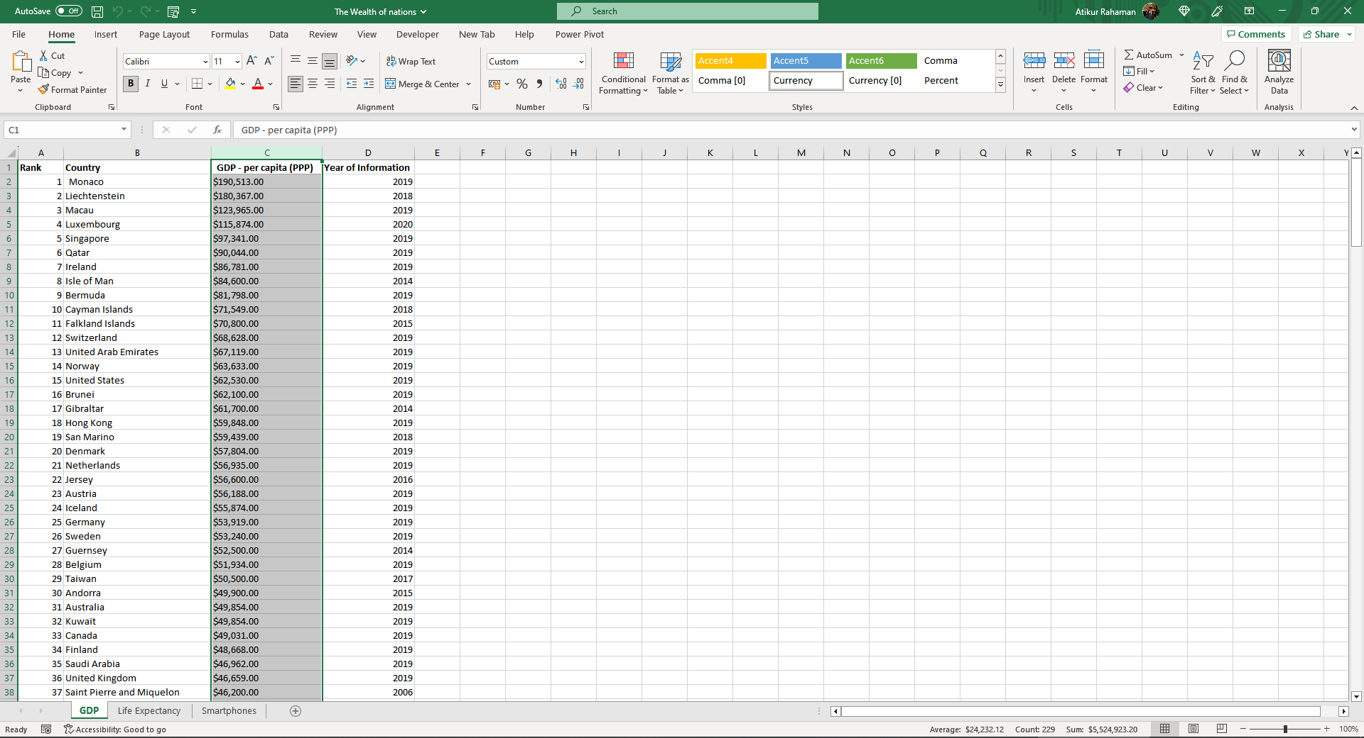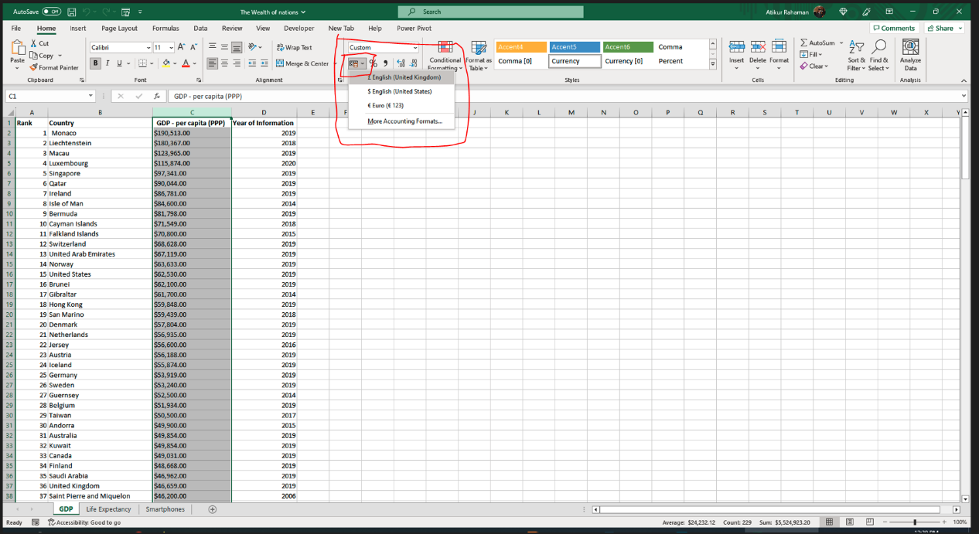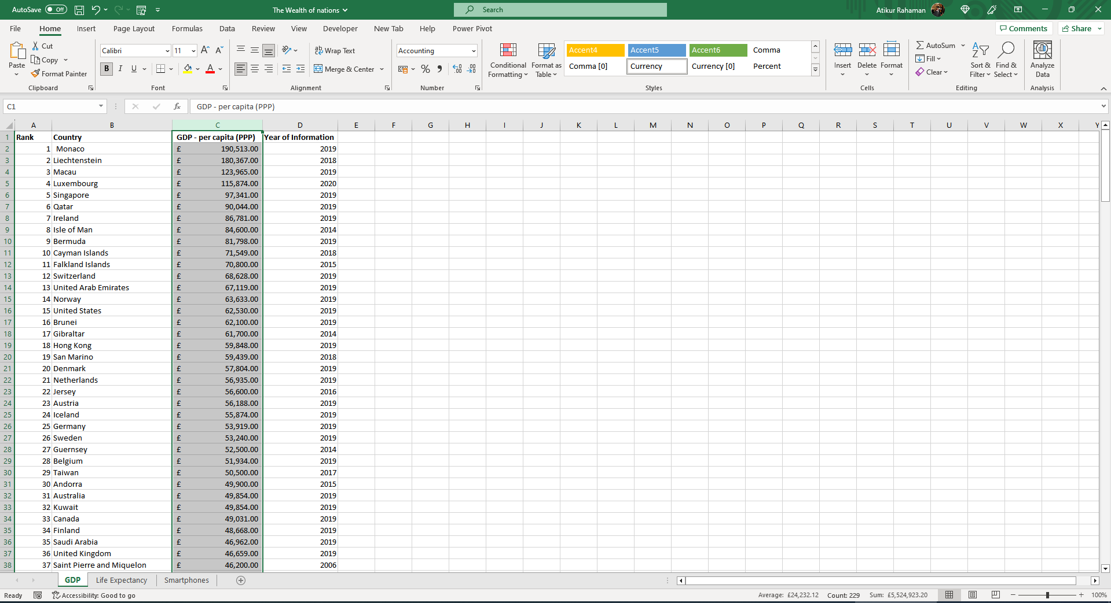

- Turn the GDP sheet into a table.
Click any cell >
then from Home tab select ‘Format as Tables’ from Styles section OR from keyboard press Ctrl +t
it will highlights with the dot dots all around the table > Create Table box will open up > double check the data range and click Ok to complete the task

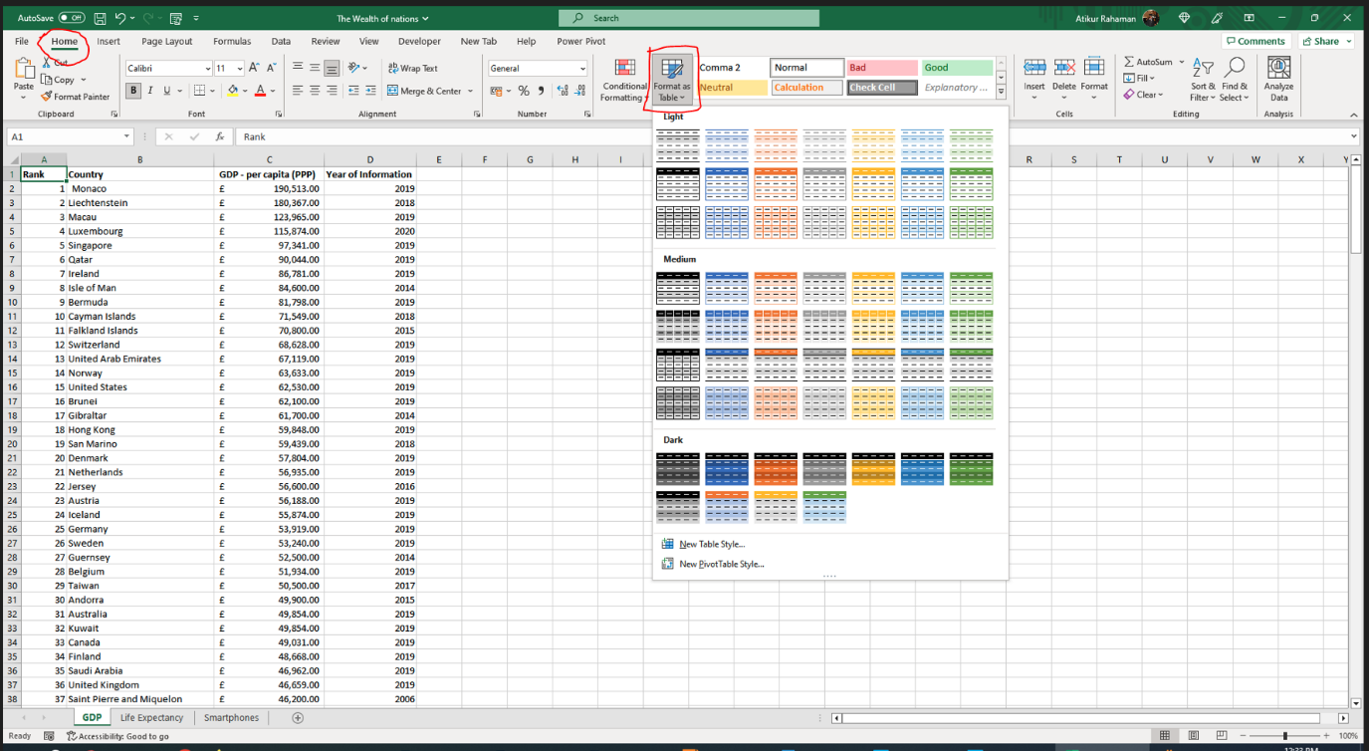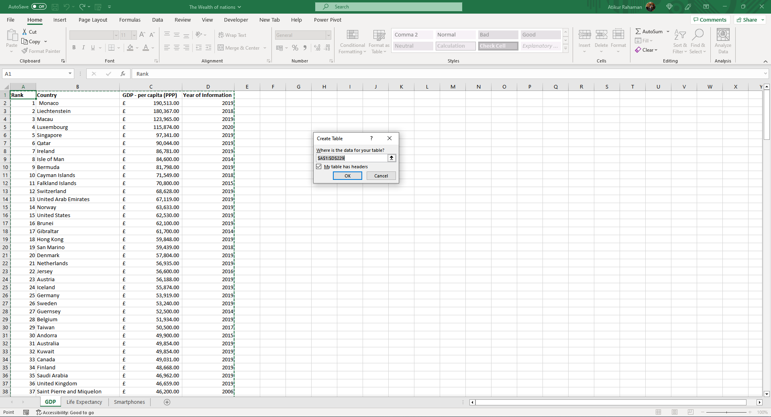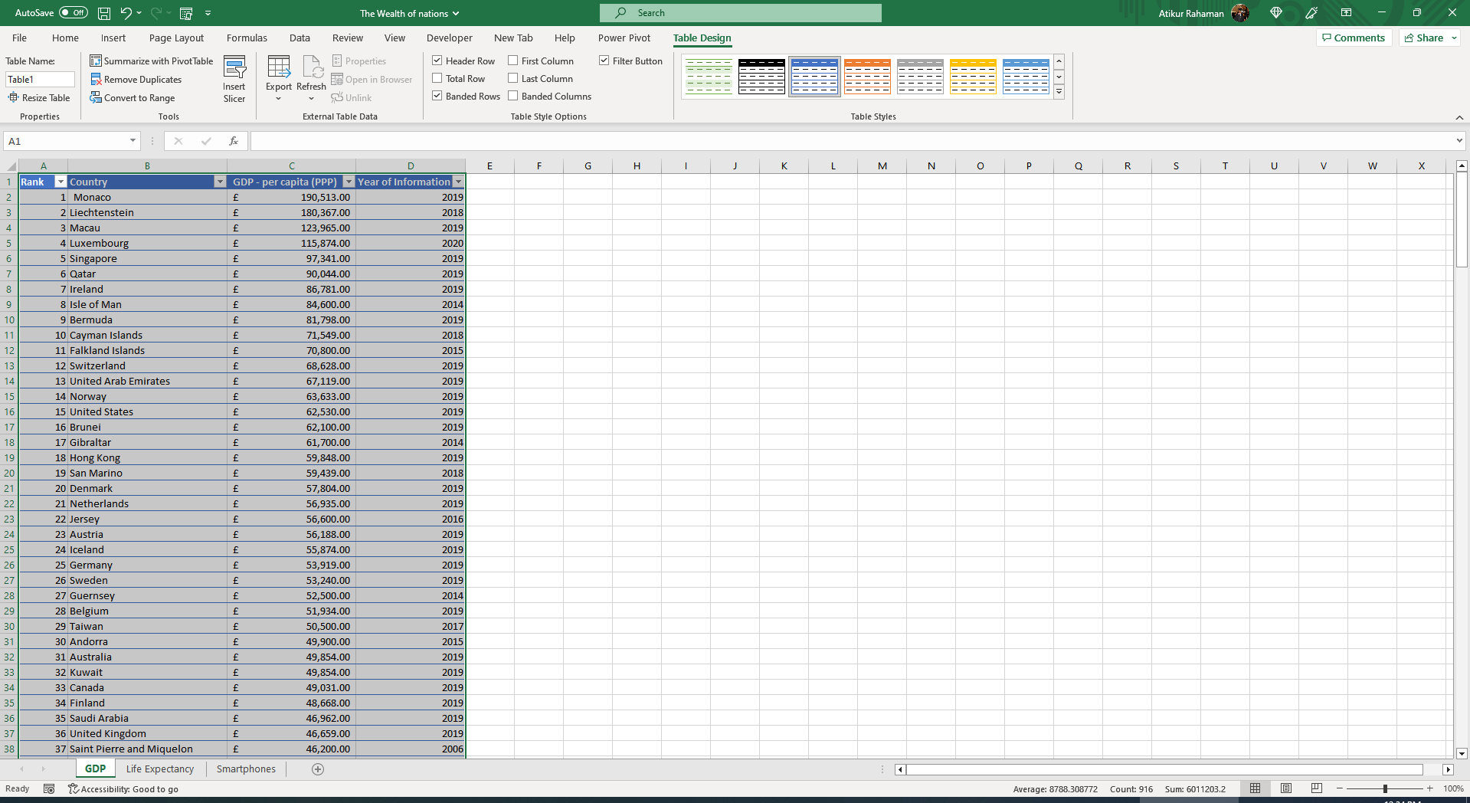

- Filter the table to display only the information for 2019 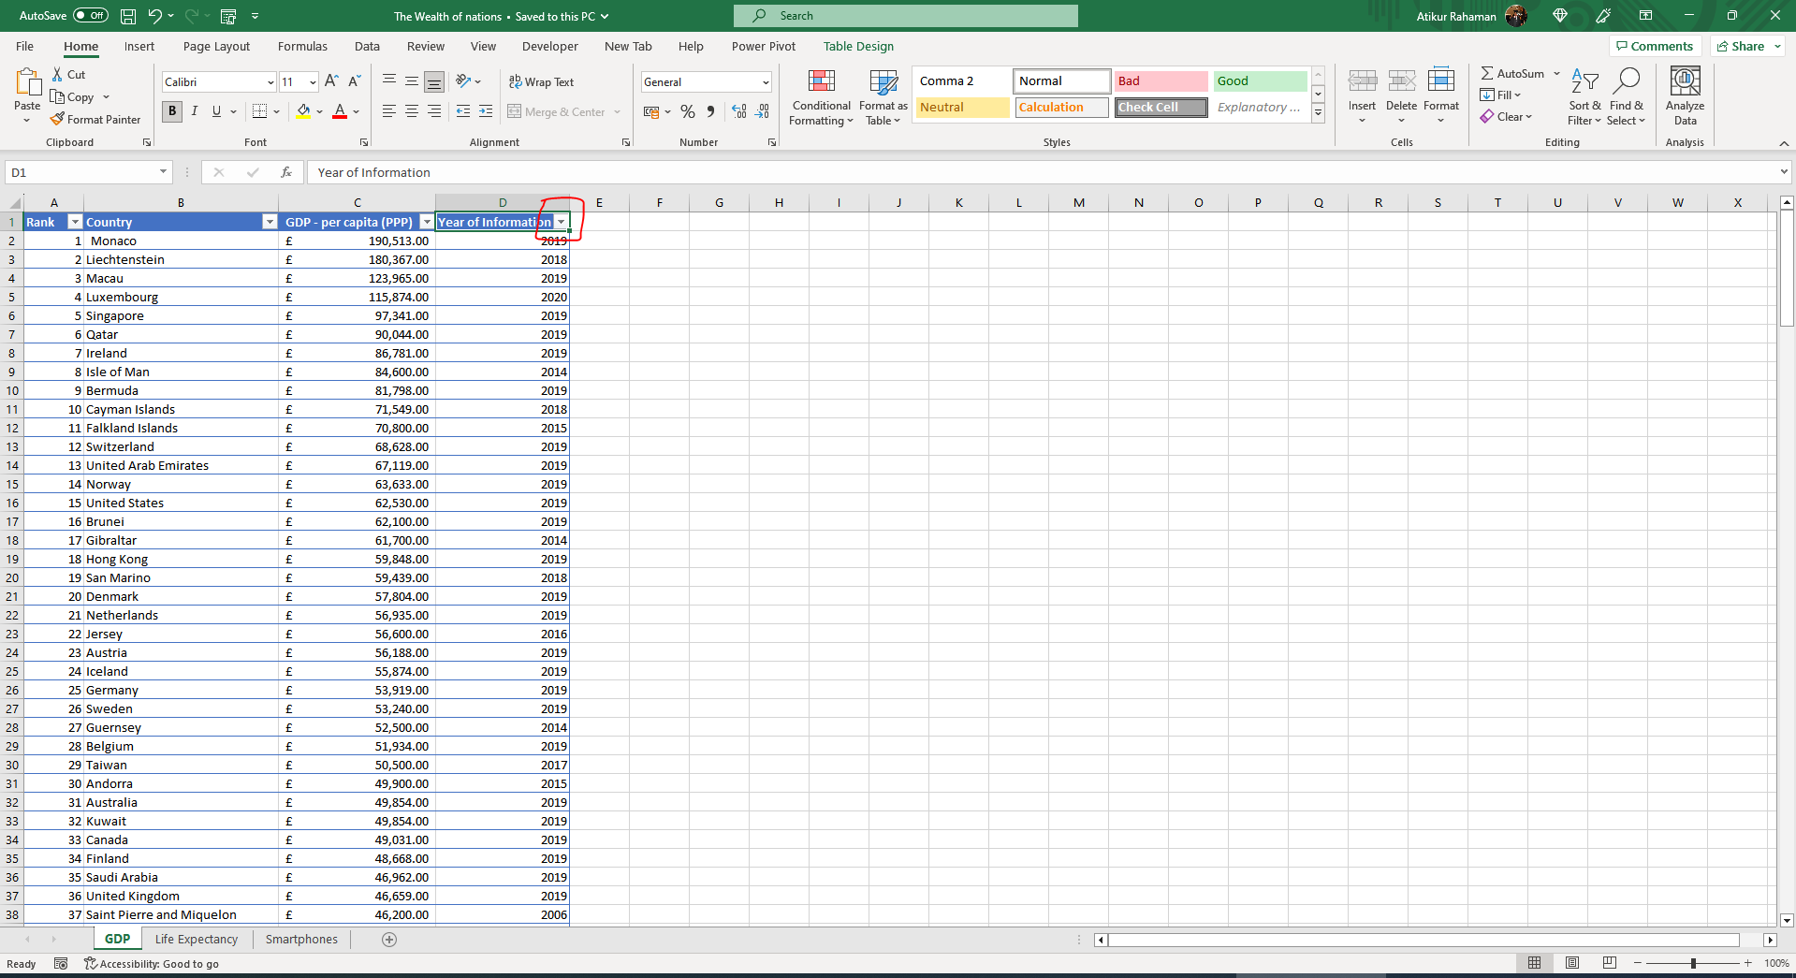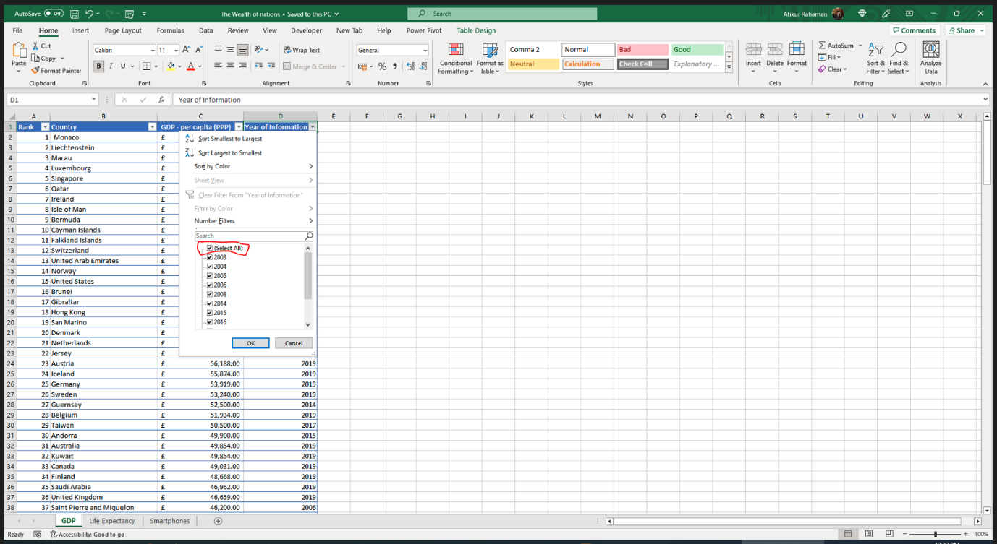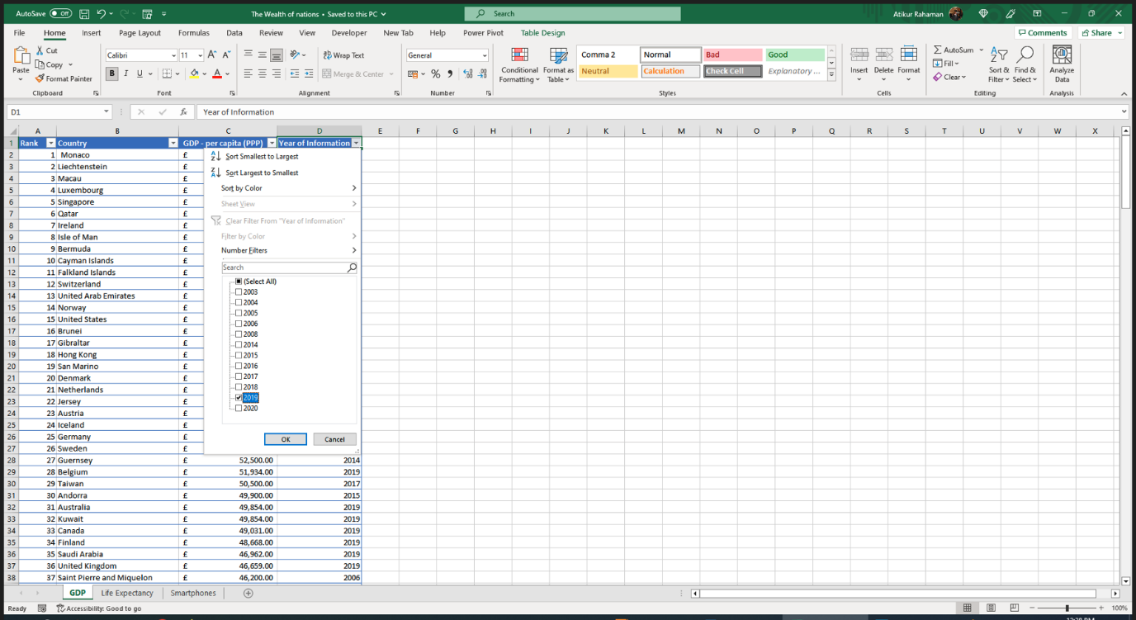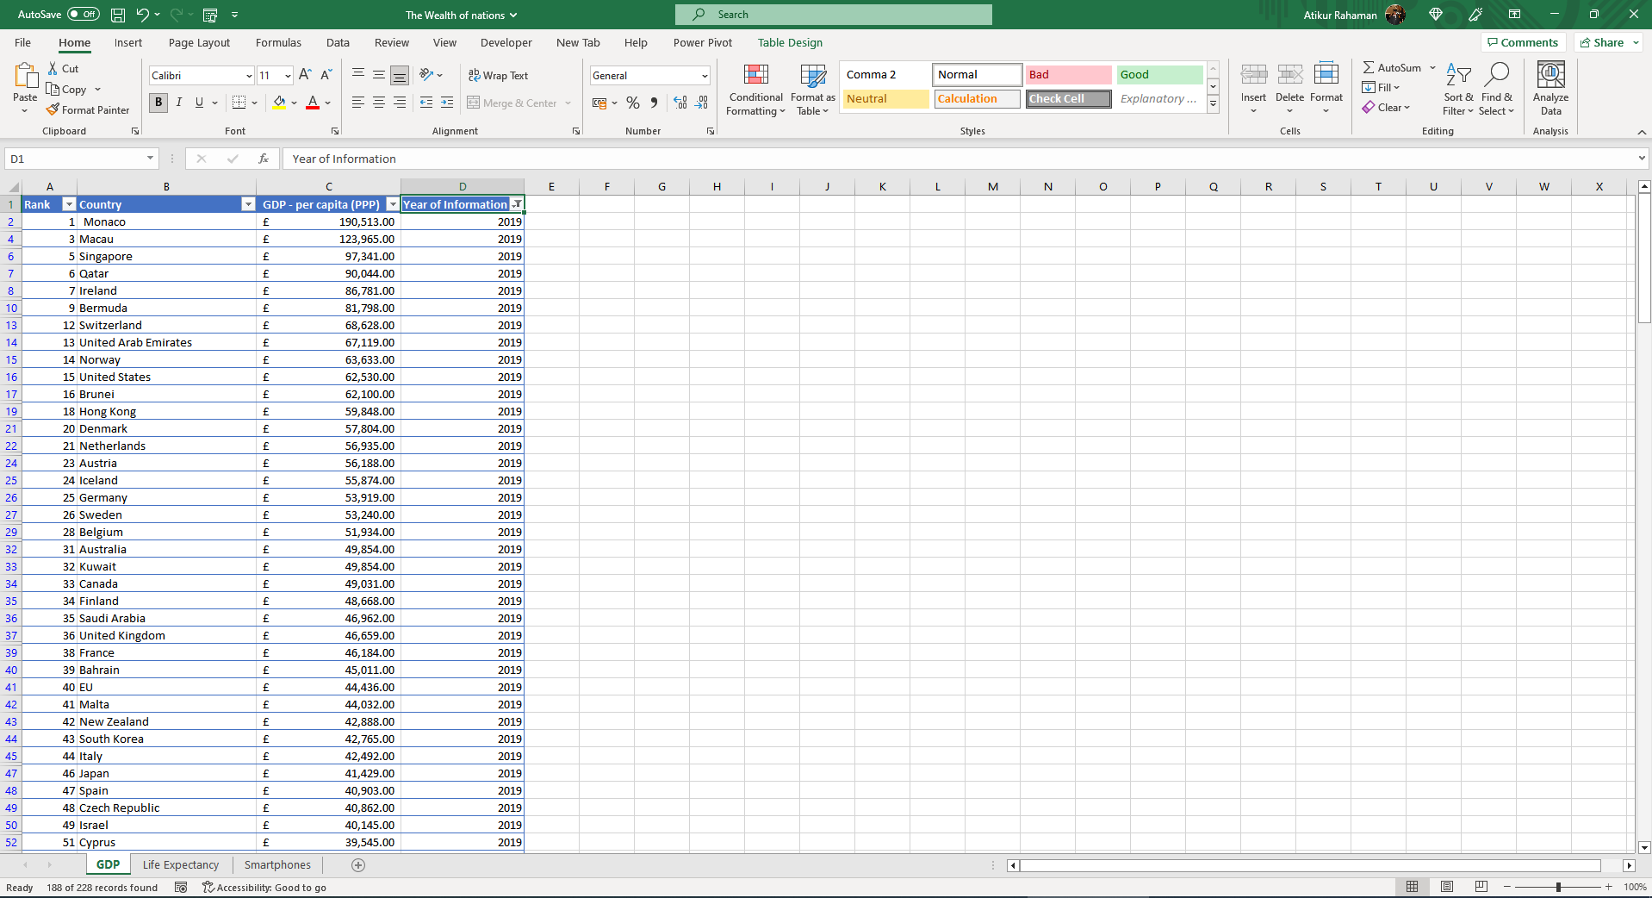

- Create a chart that will only display the following data ‘Rank’, Country and ‘GDP-per capita (ppp)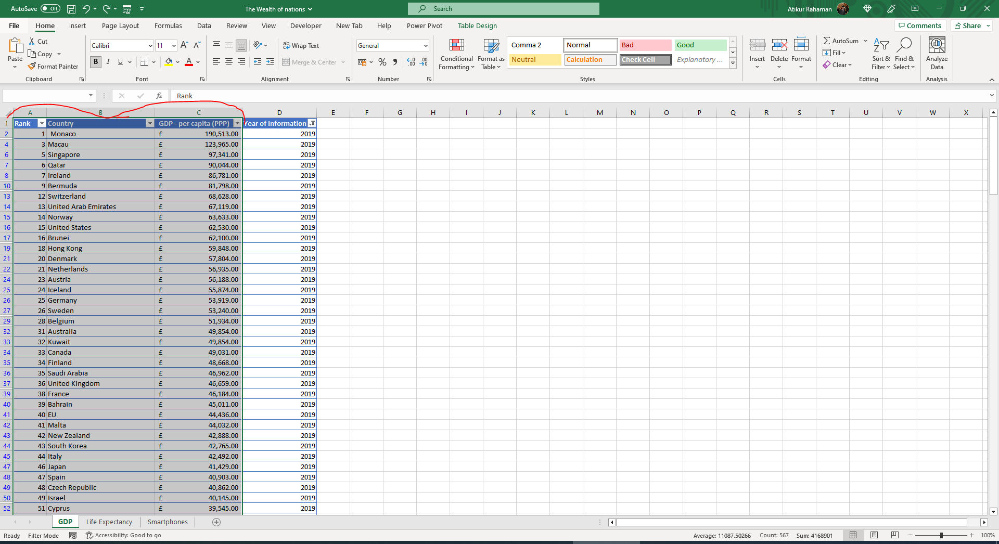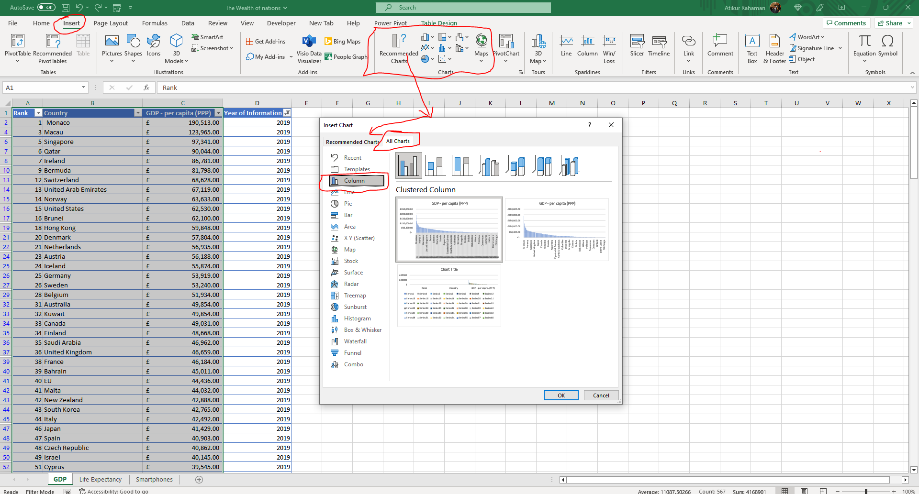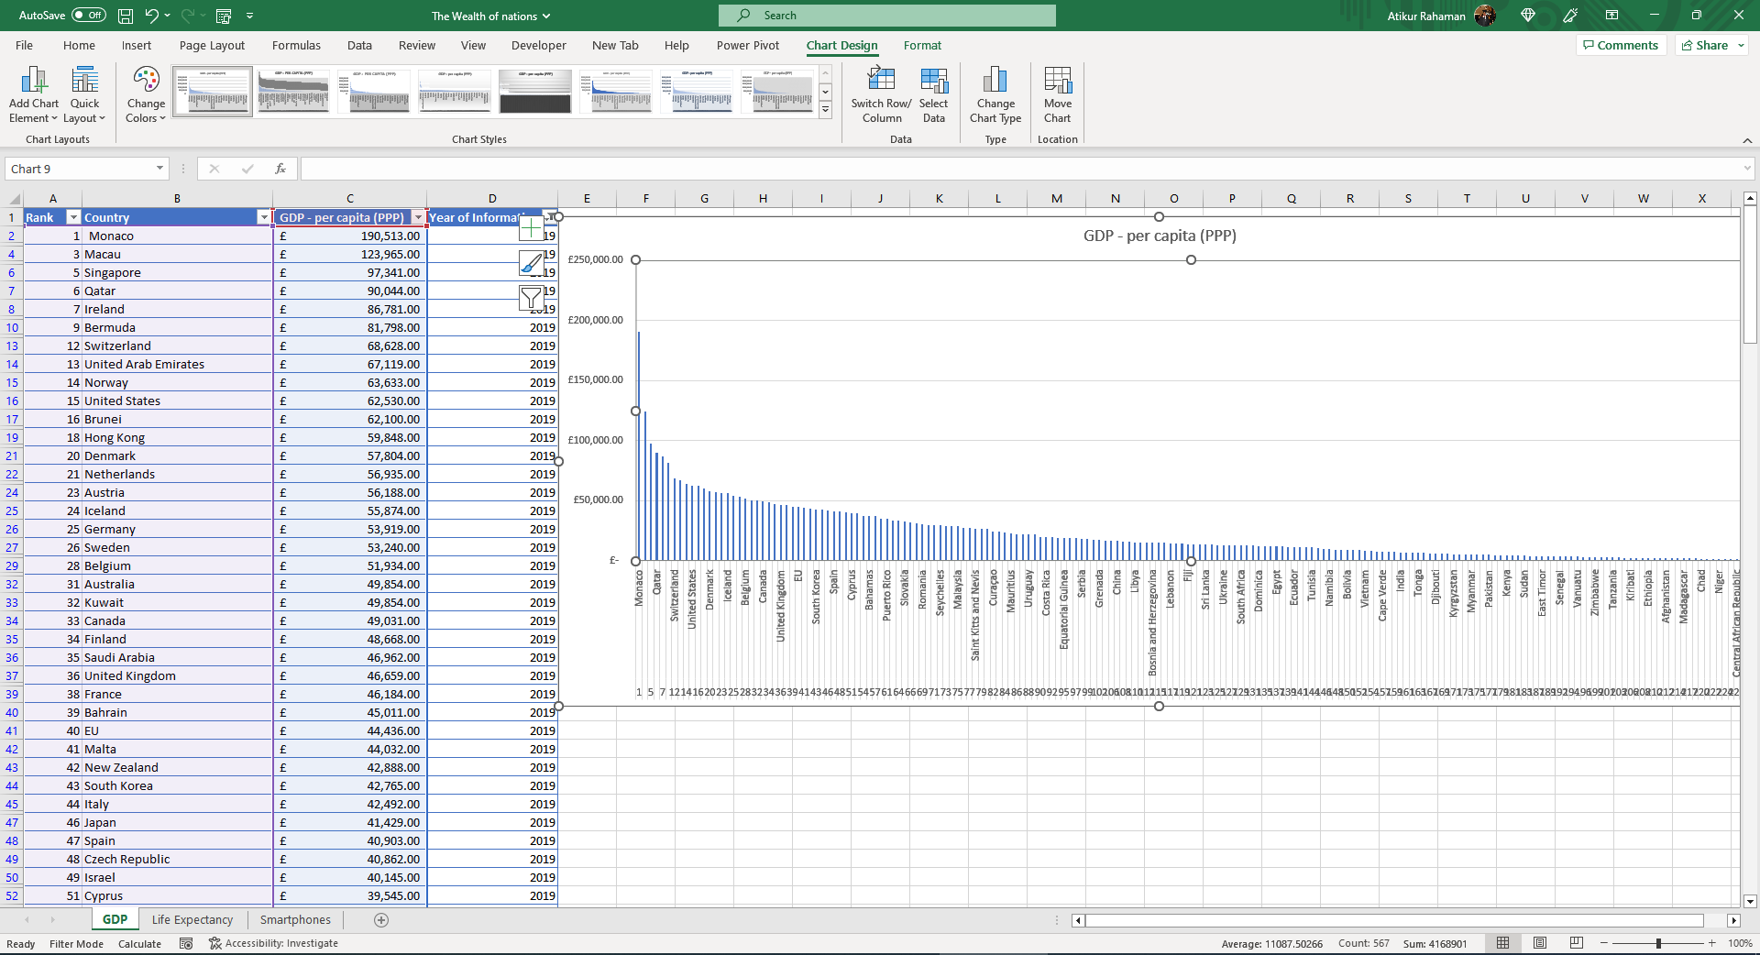

- a. Add a title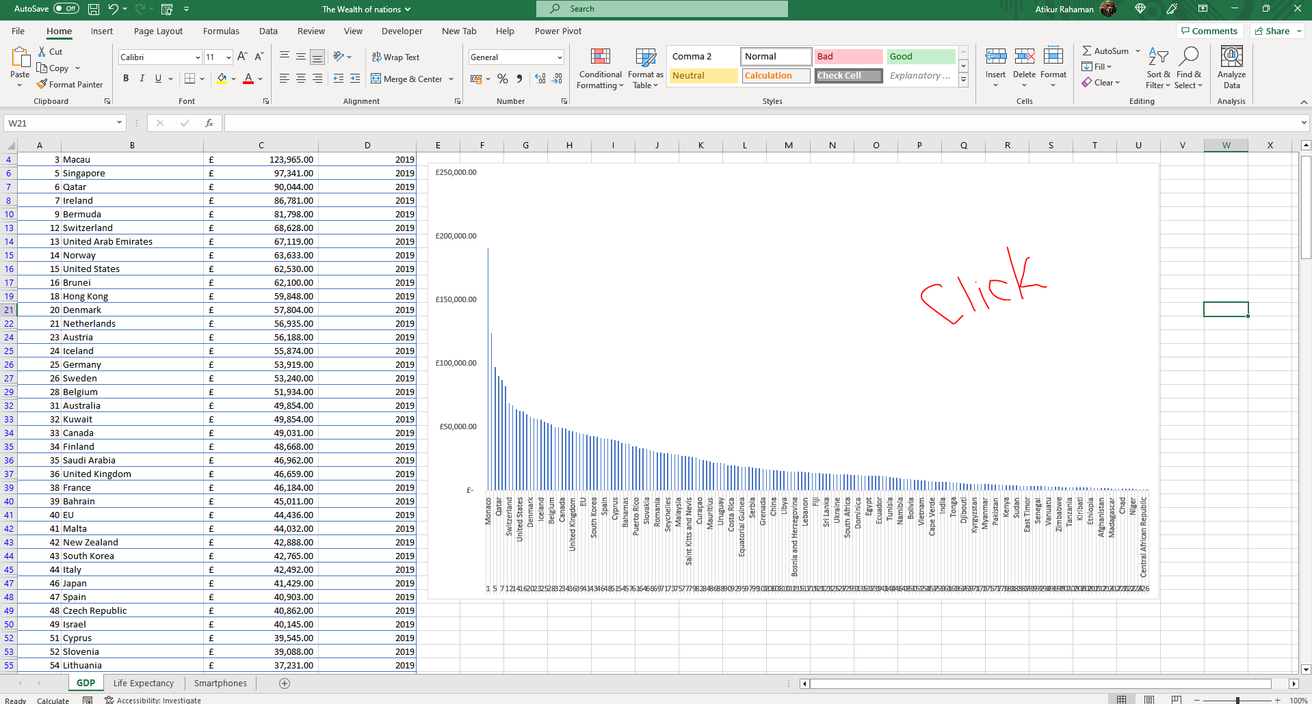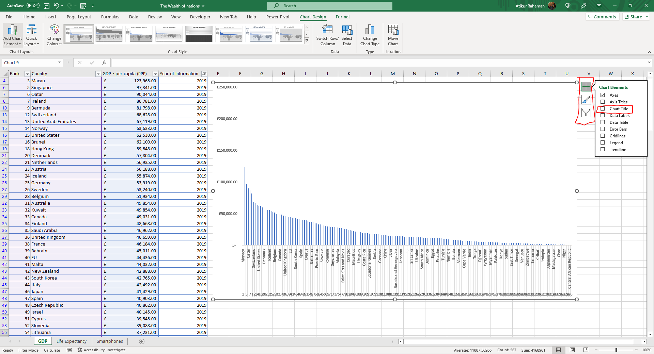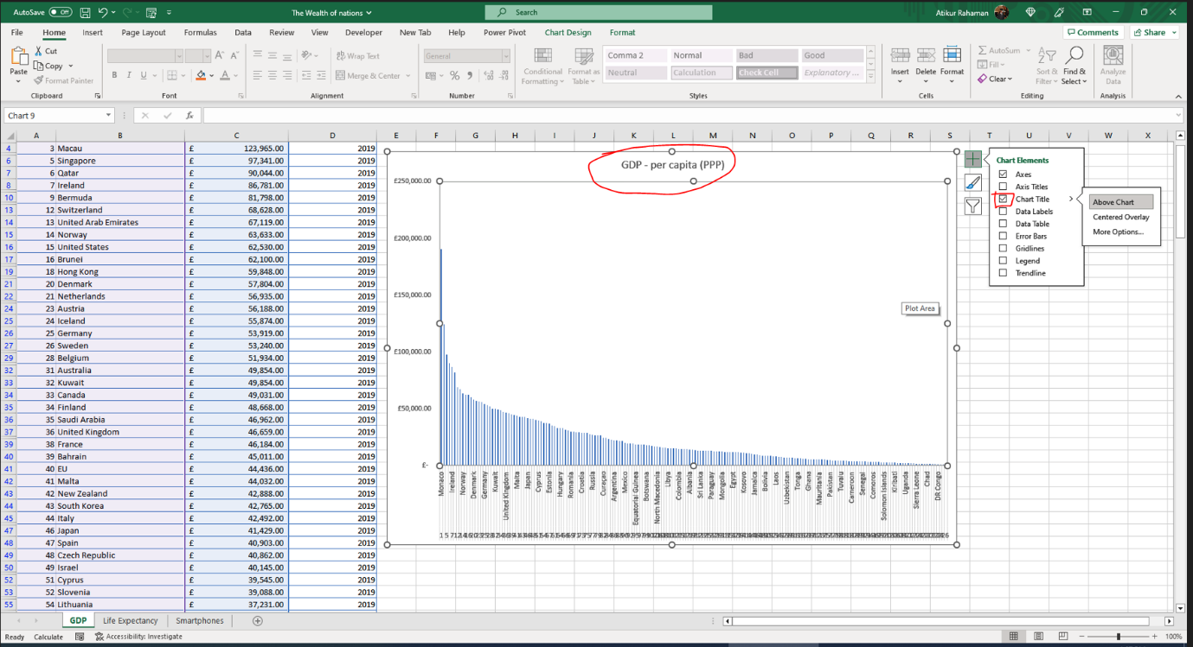

b. Add X and Y axis labels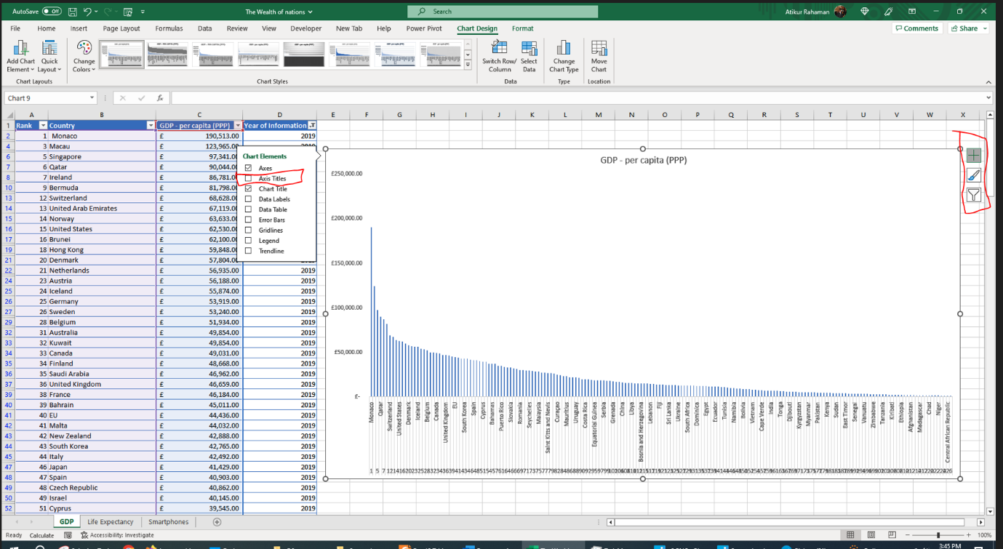

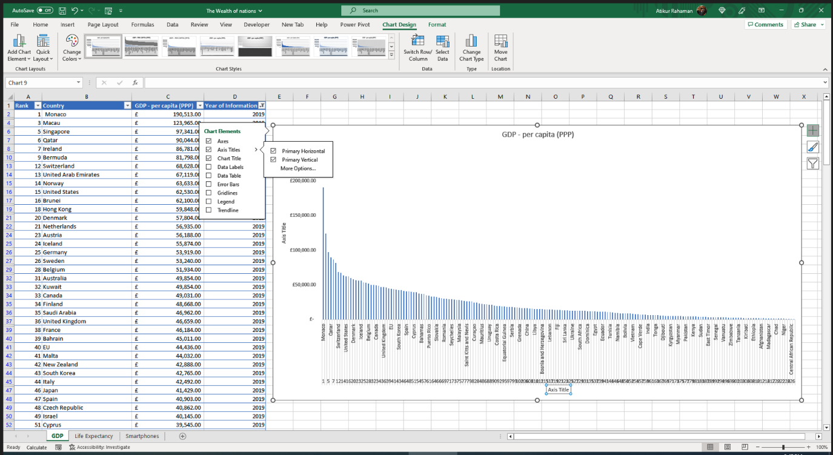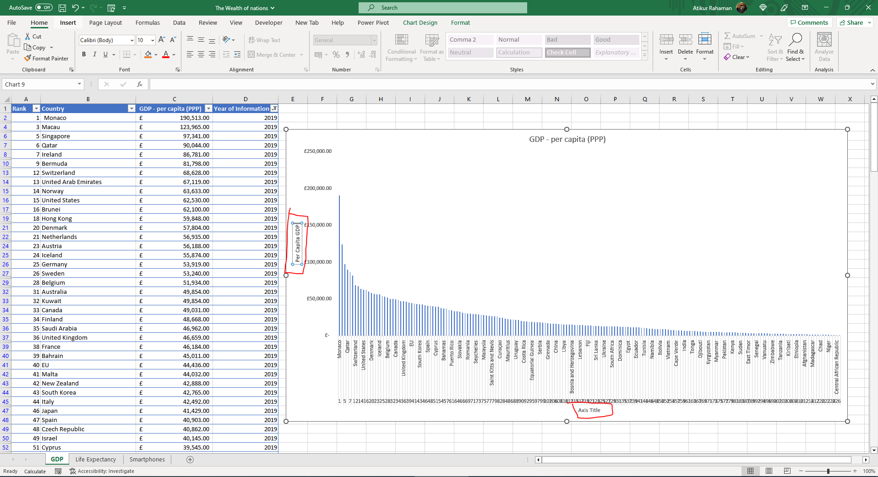

C) Make the chart visually pleasing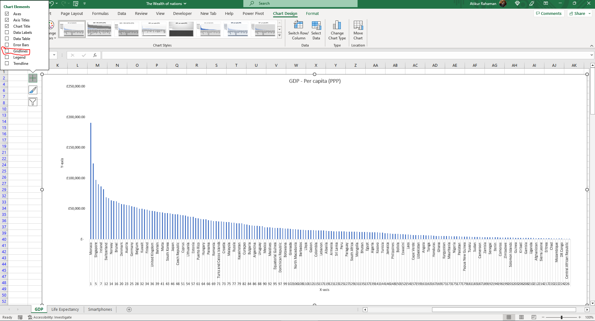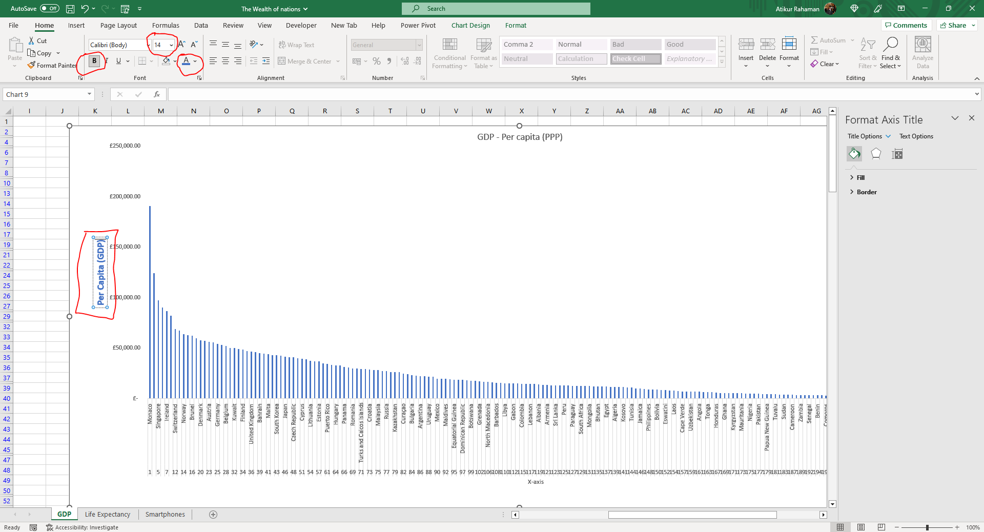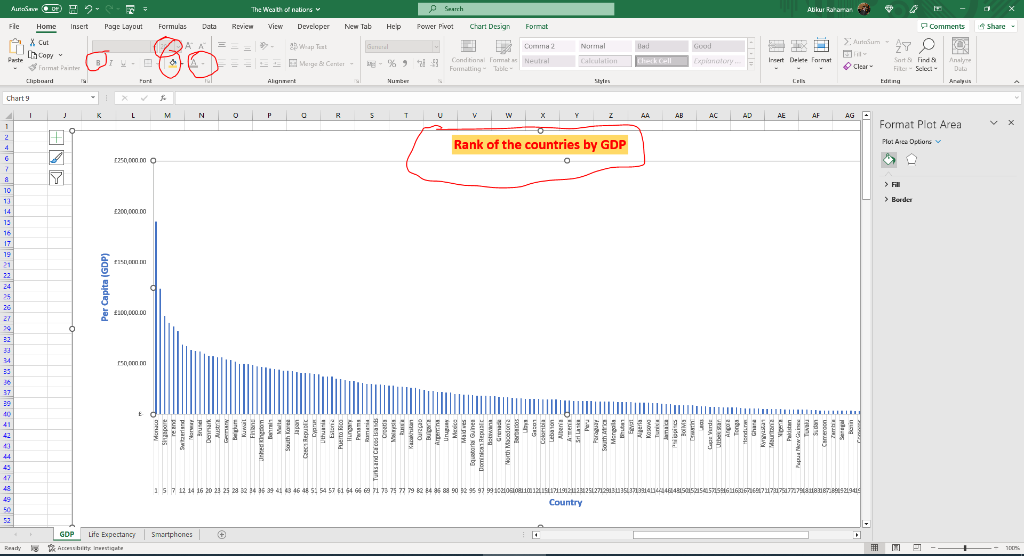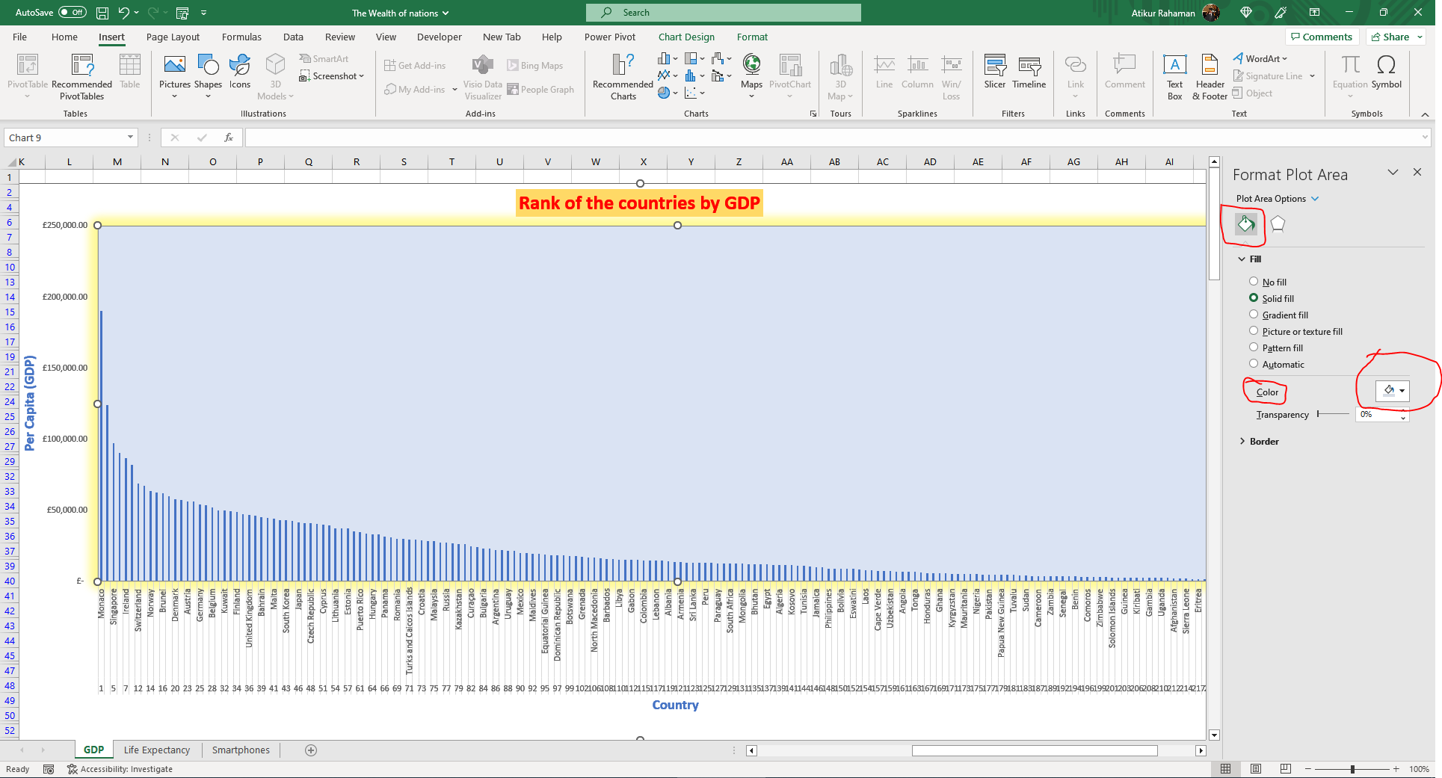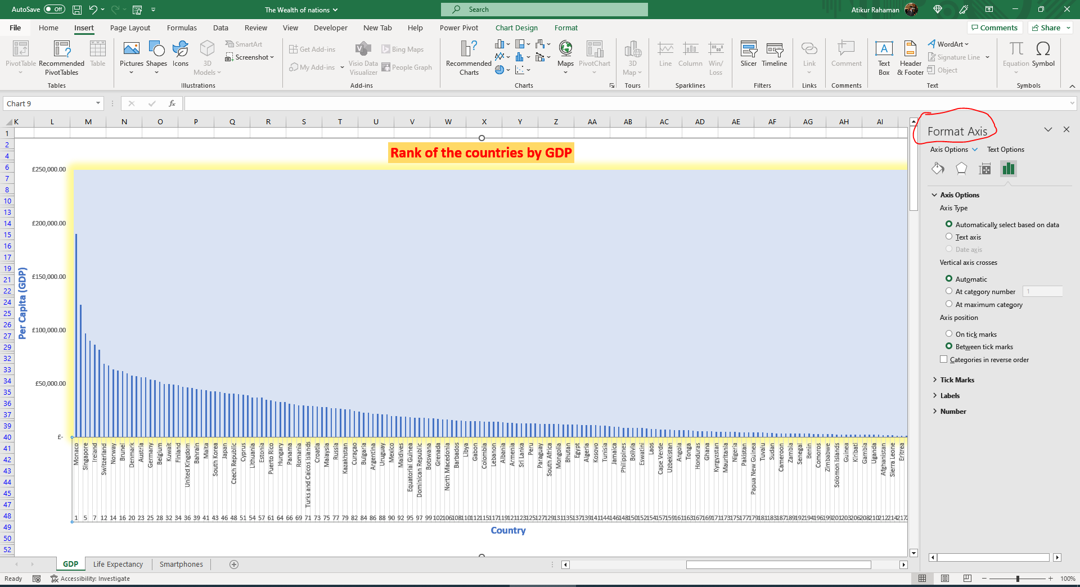

- Move the chart to new Sheet and label it a suitable name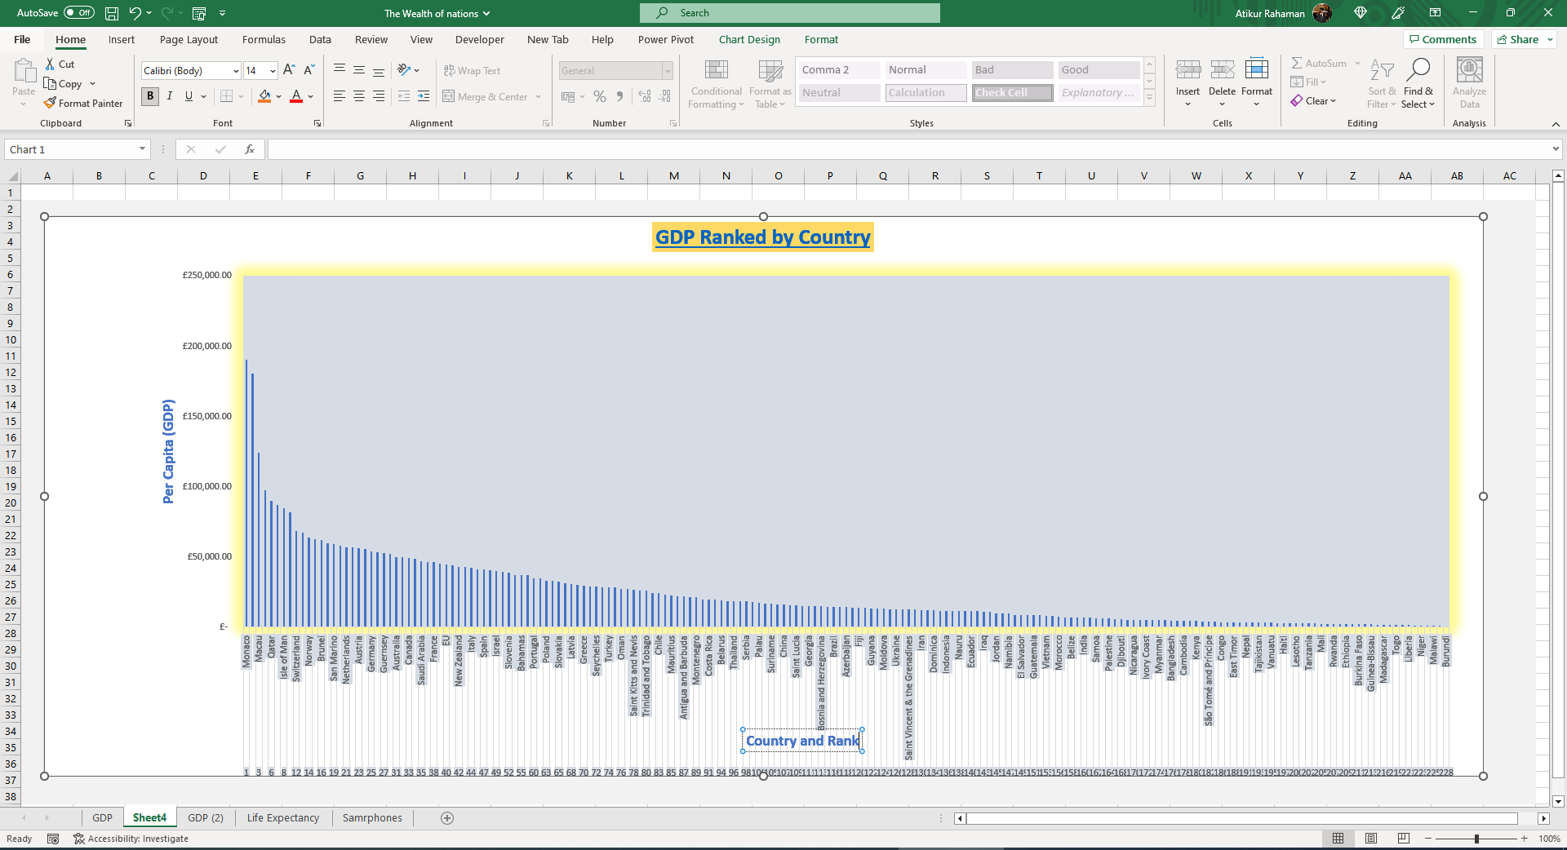

- Create a sort for top 20 highest ranking countries.

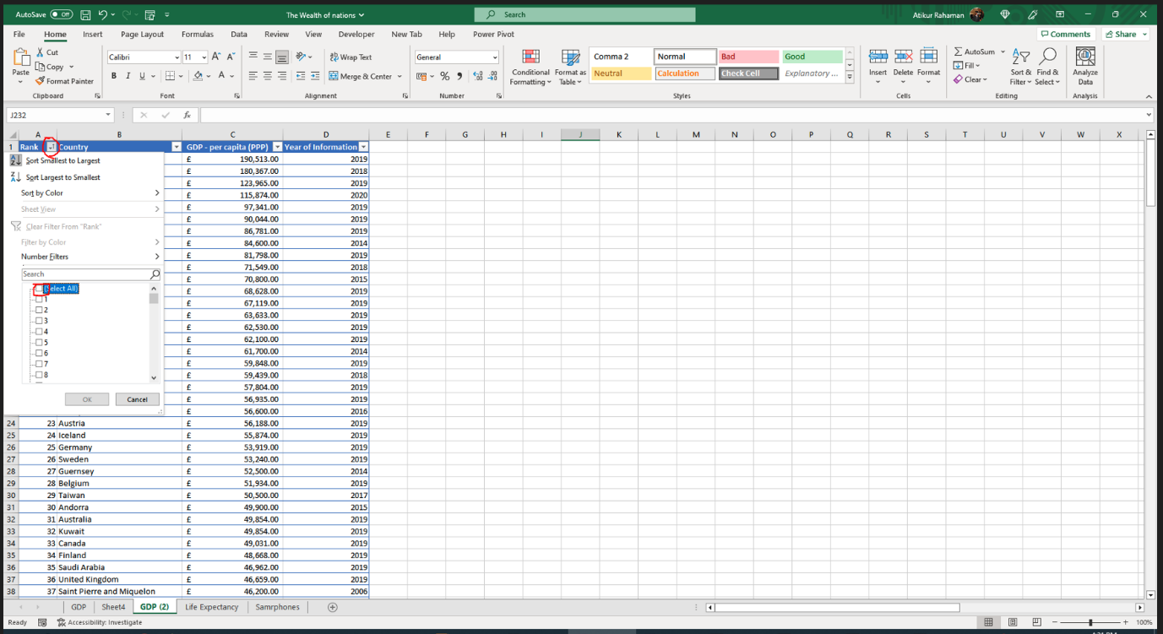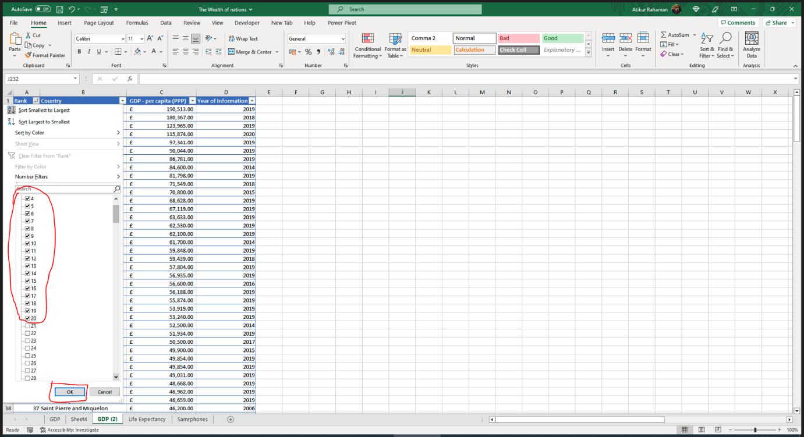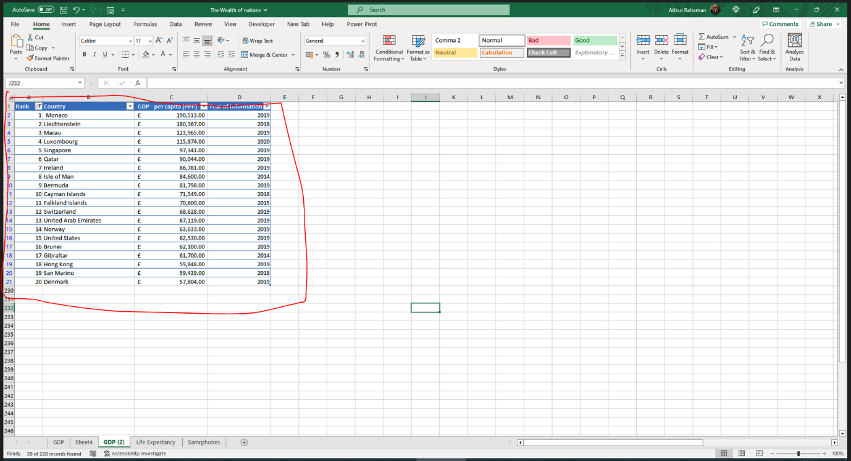

- New bar chart for top 20 countries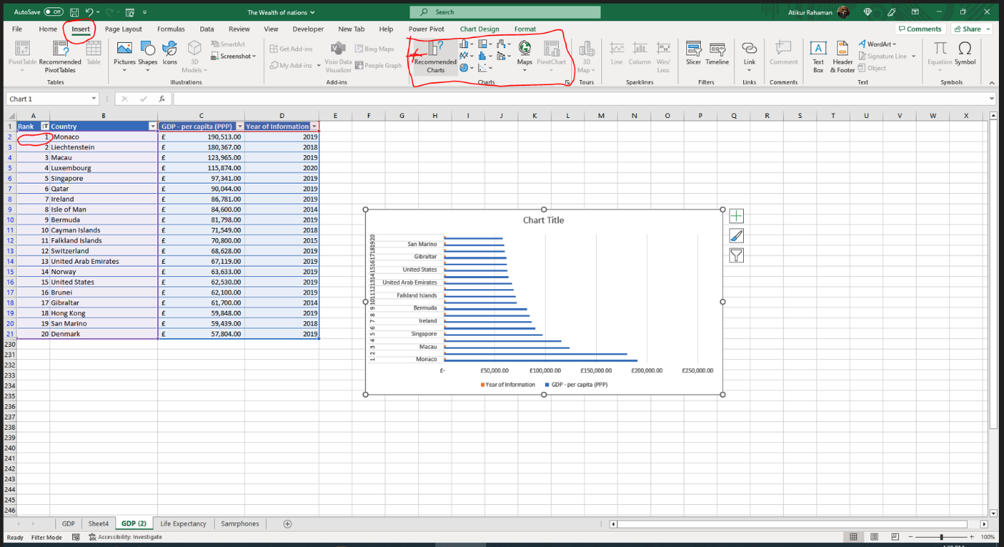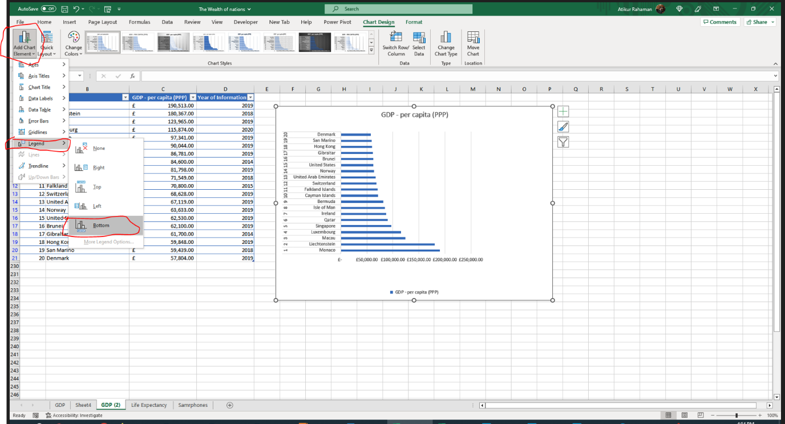

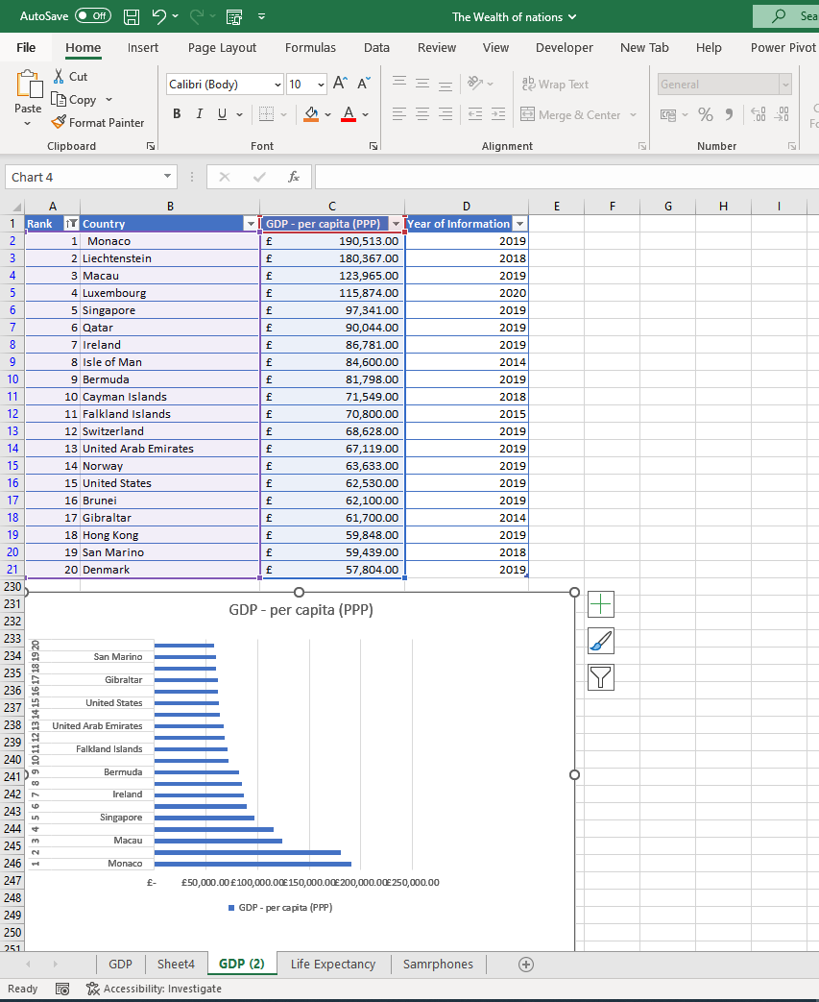

- Colour the background by highlighting the area….

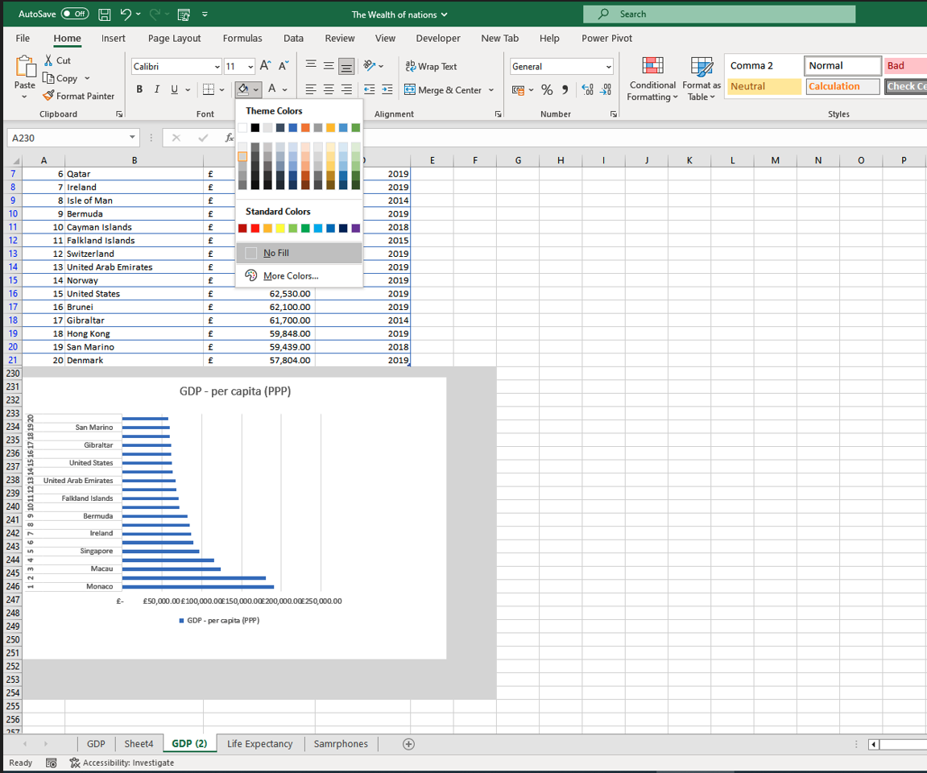

MACRO TASK

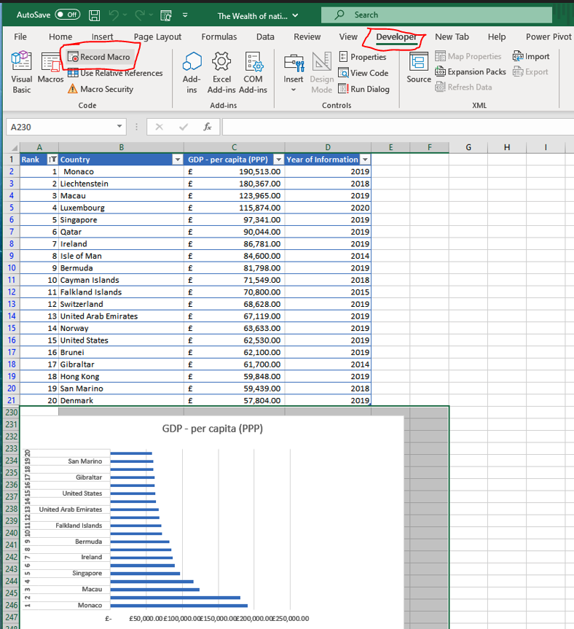

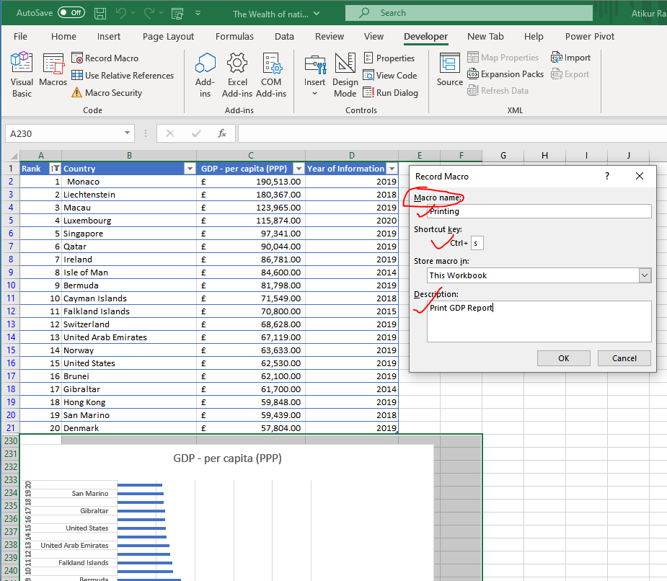

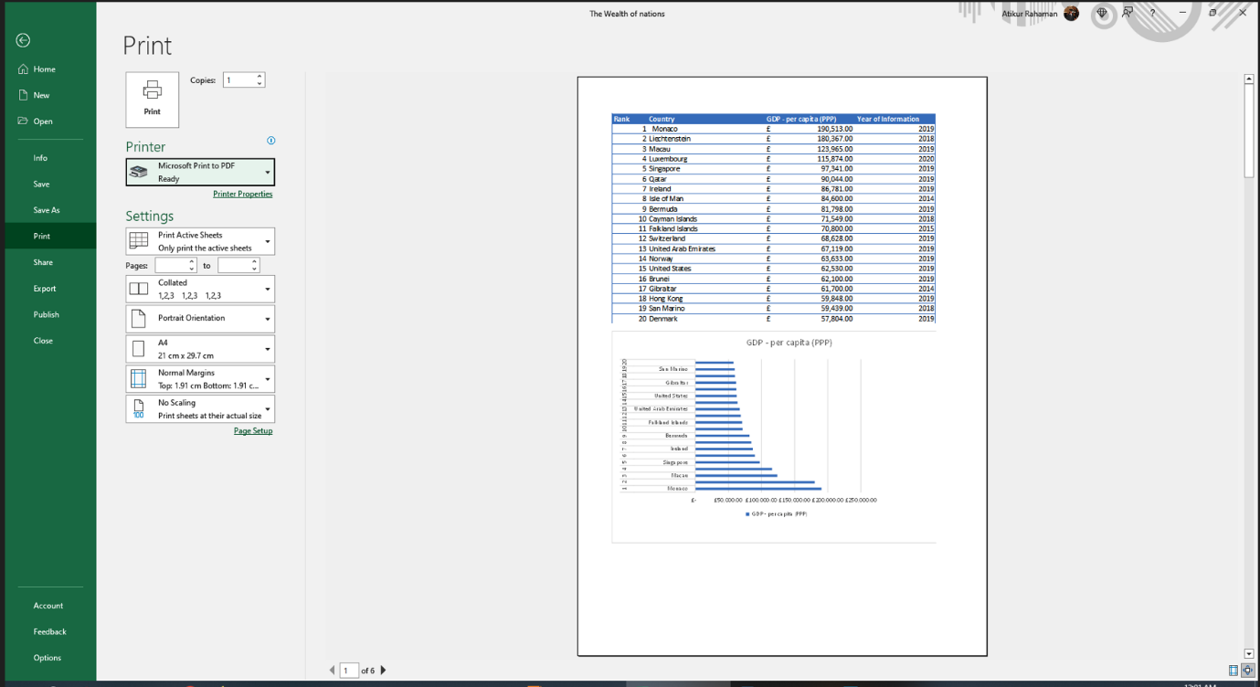

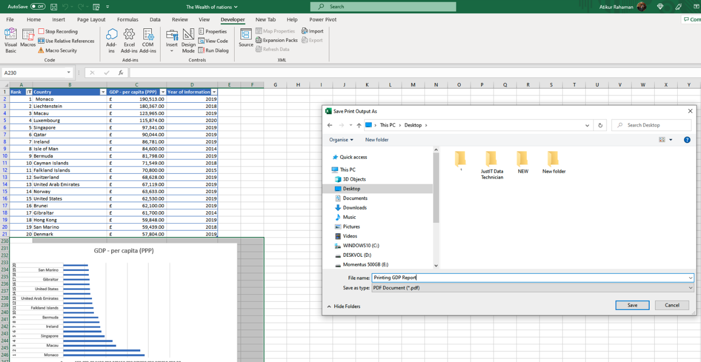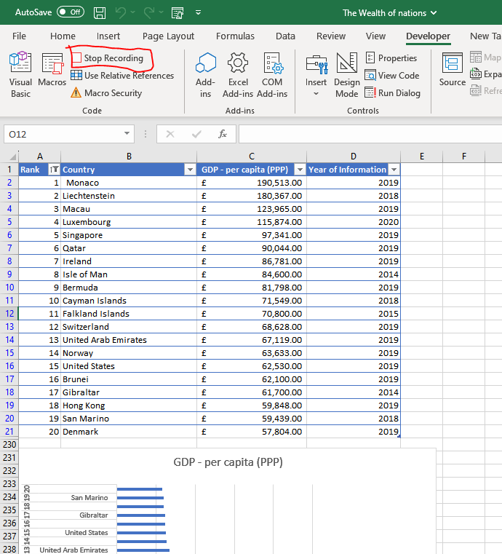

Creating buttons

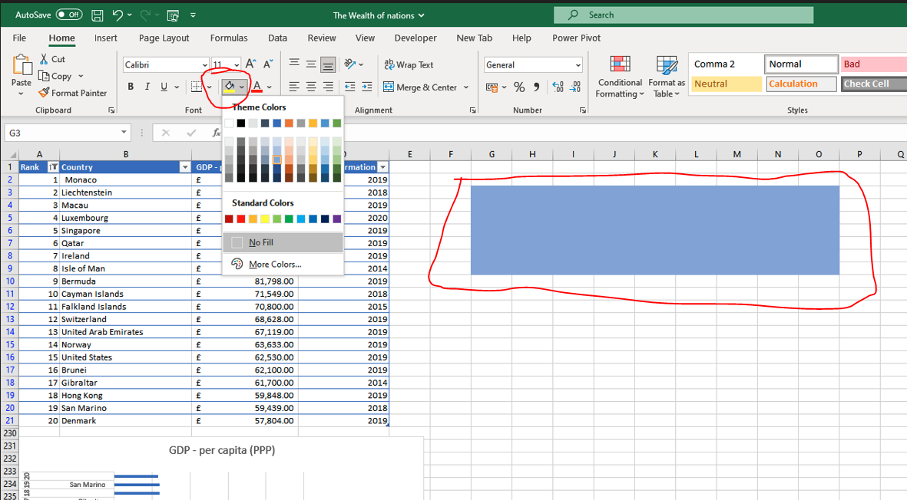

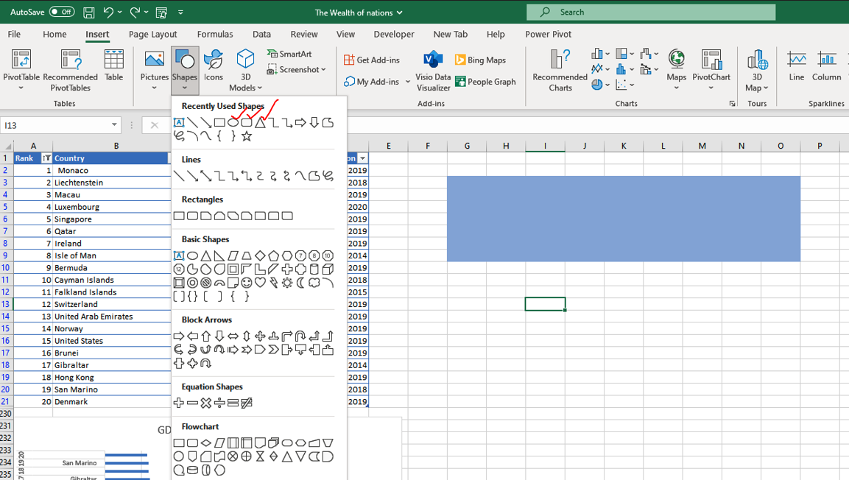

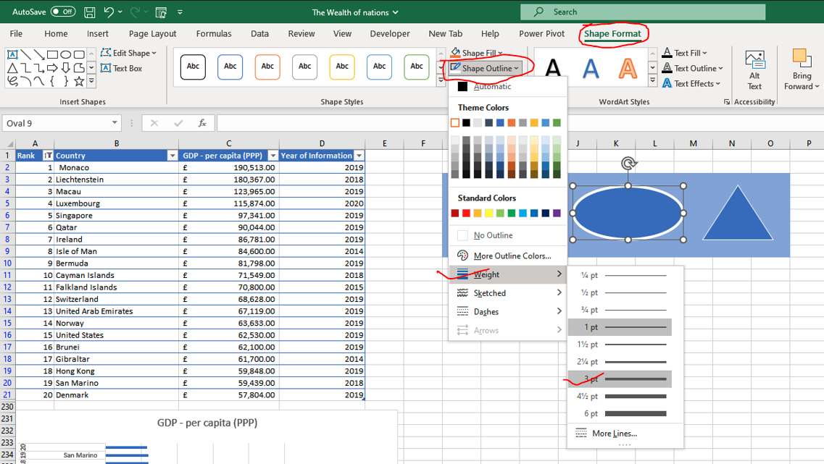

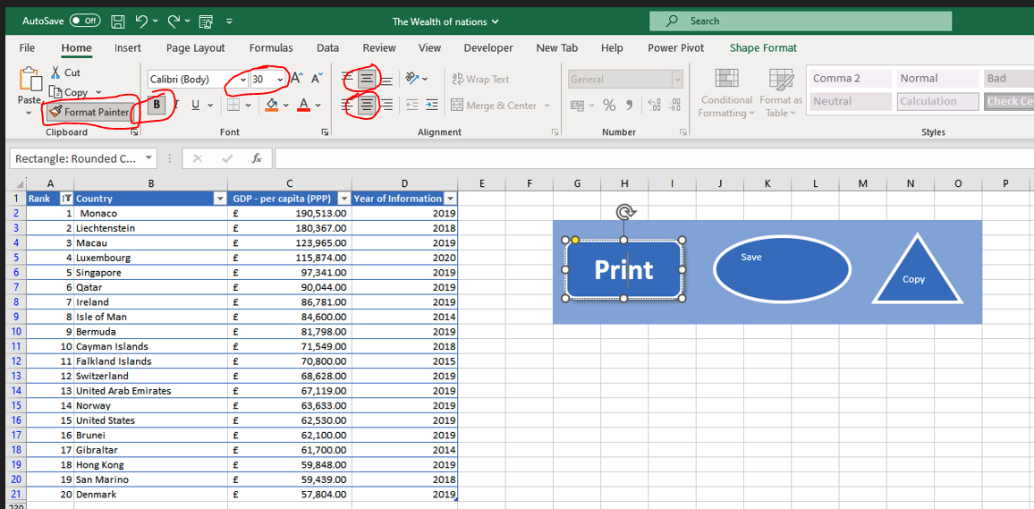

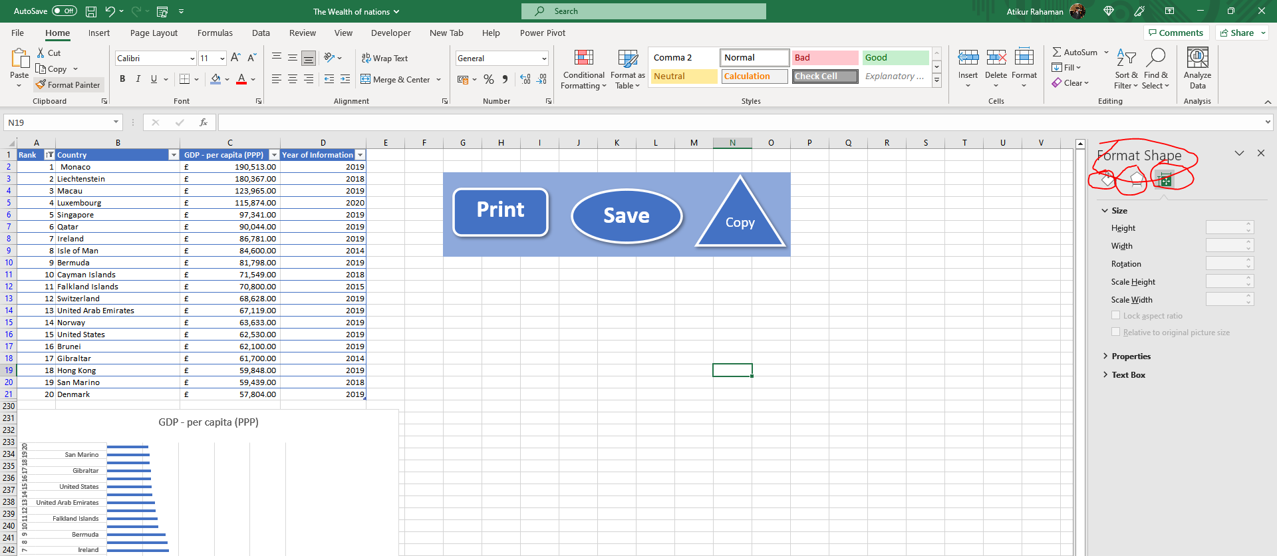

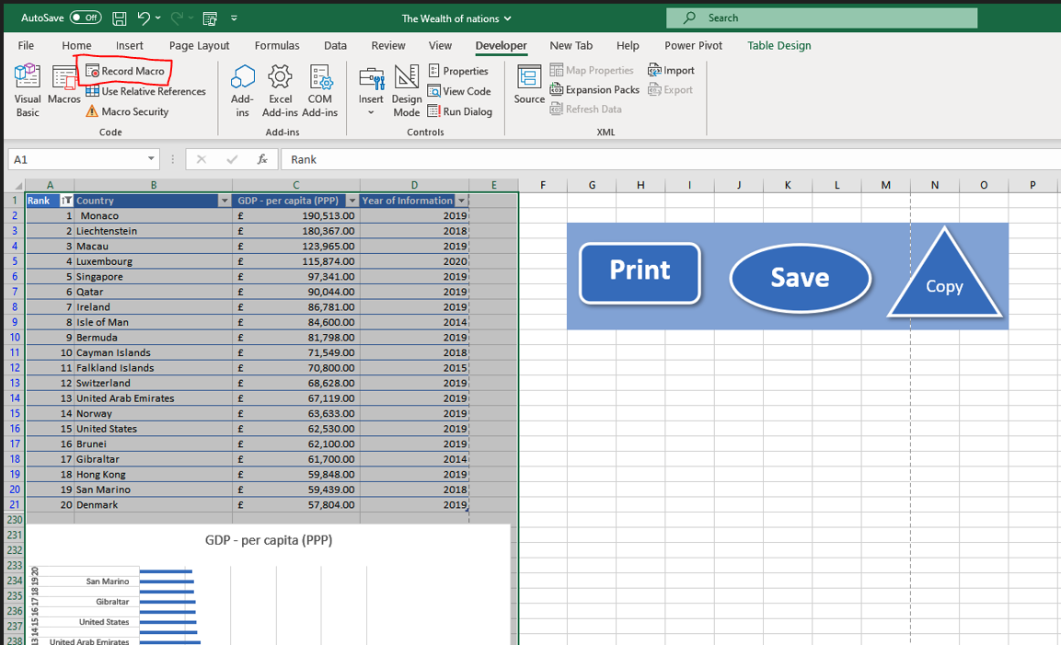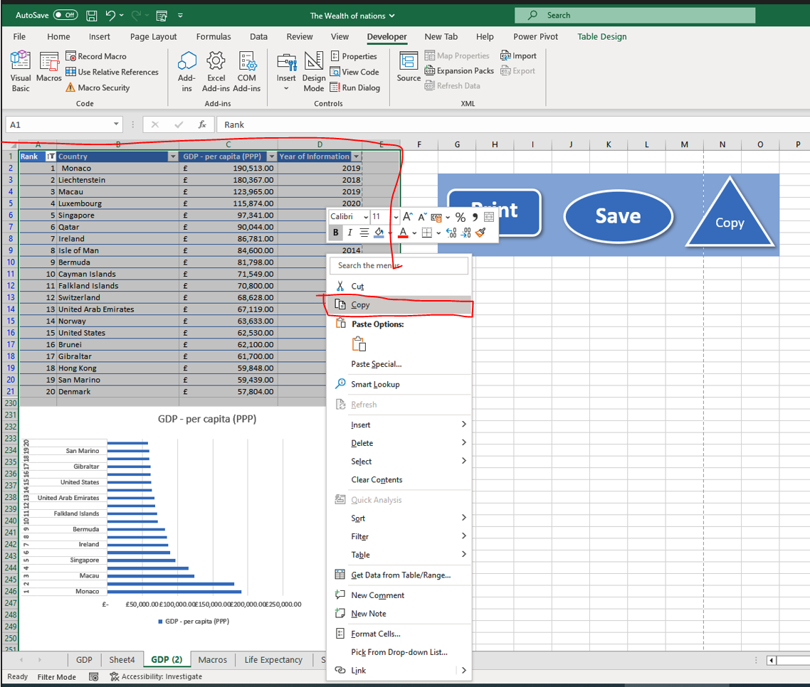

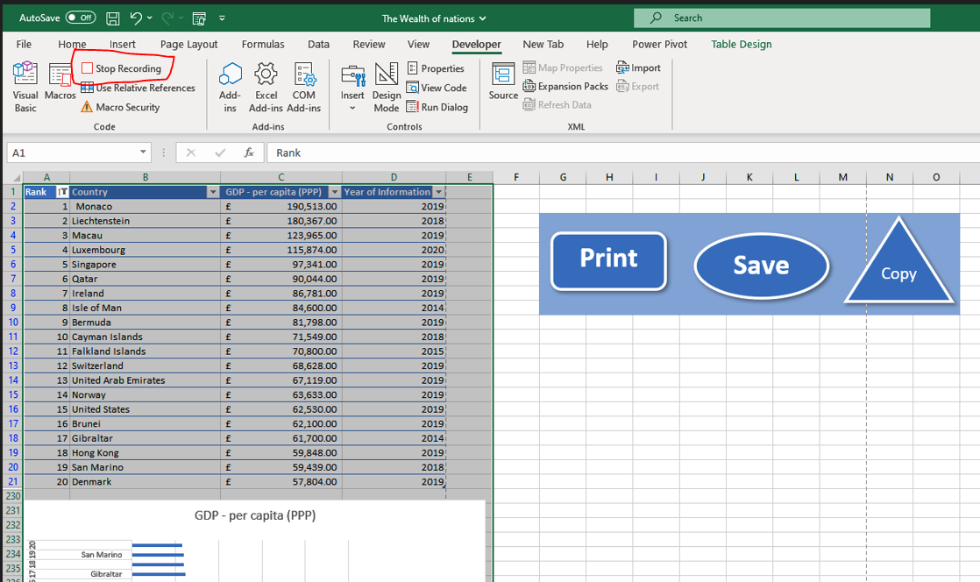

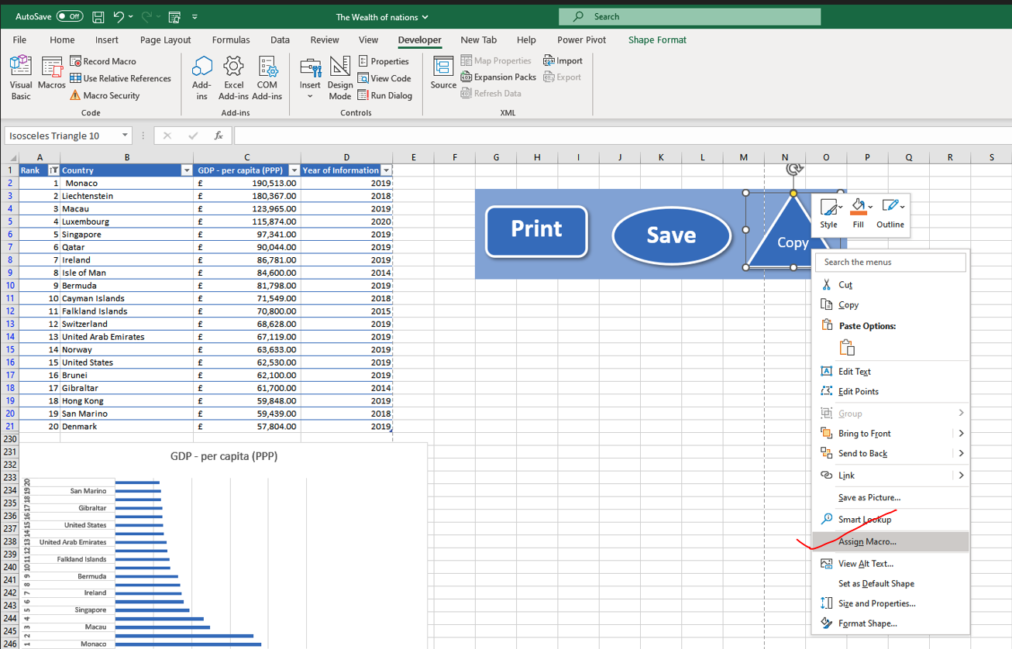

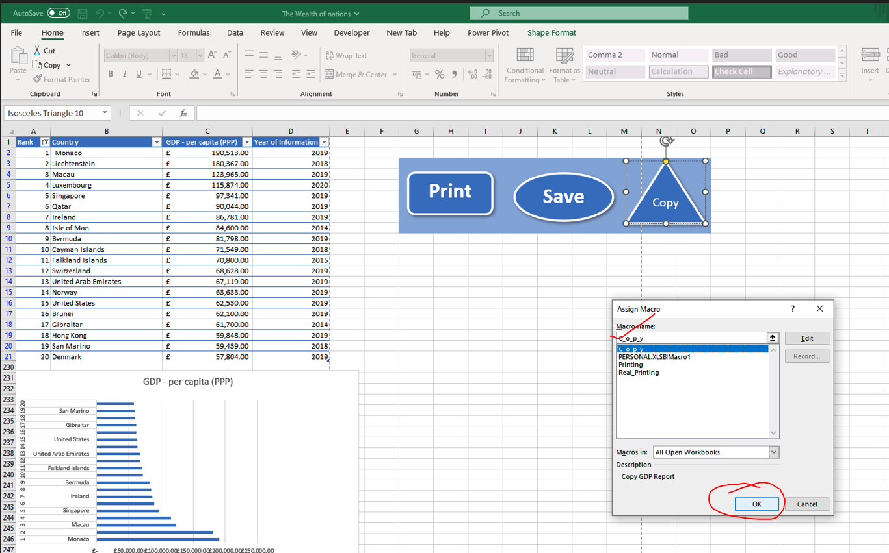

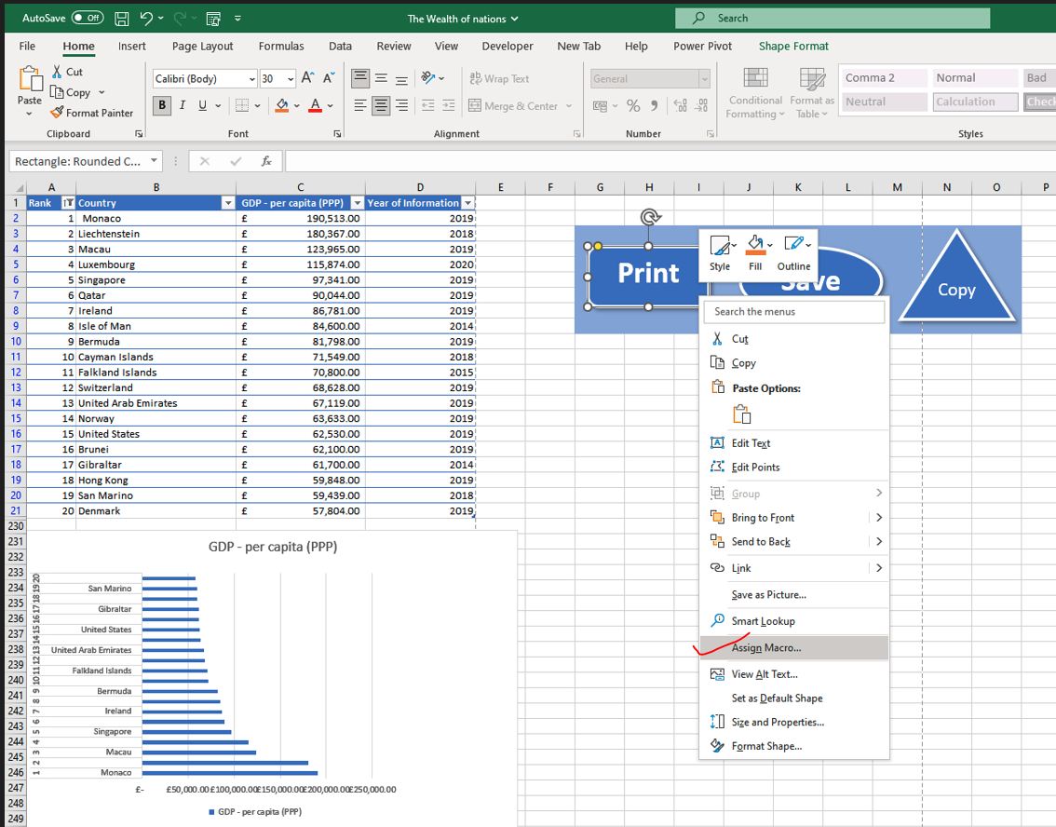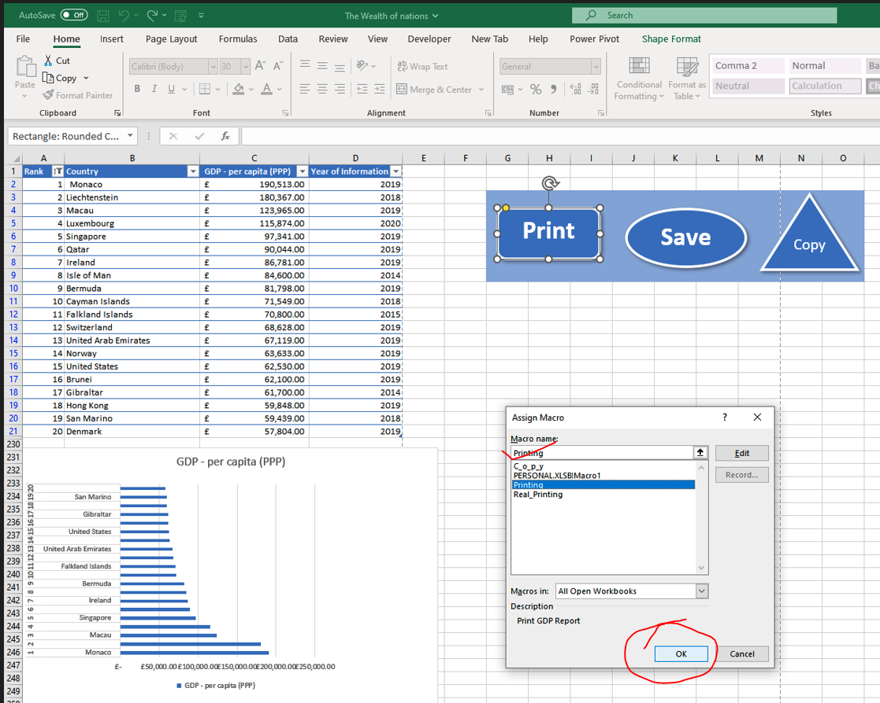

2. Using the copy macro, copy the sheet and then paste it into a new word document

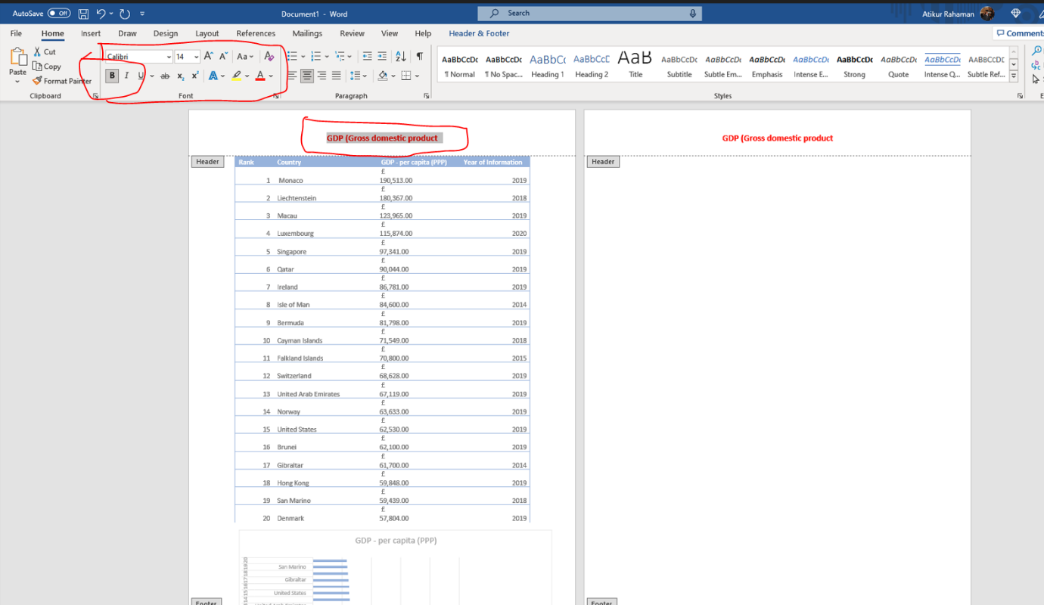

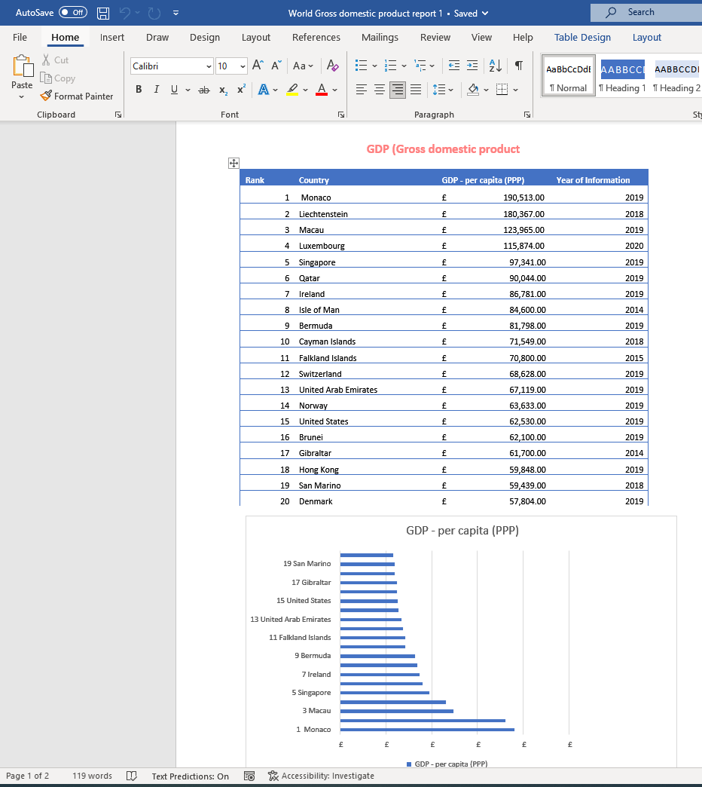

3.Save your documents as ‘Word Gross domestic product report 1’

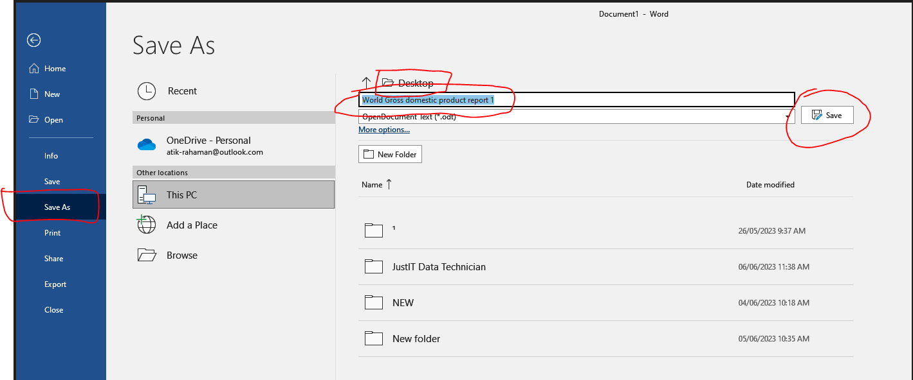

6. Header and Footer for the table

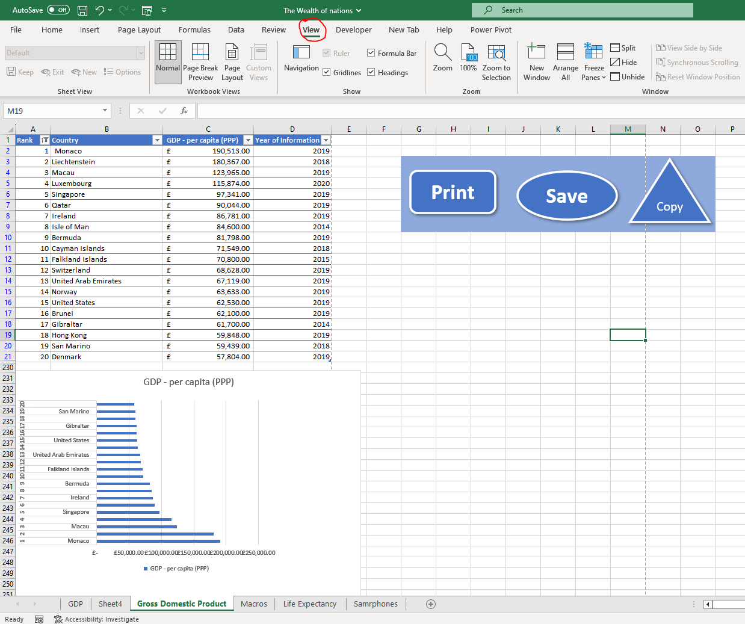

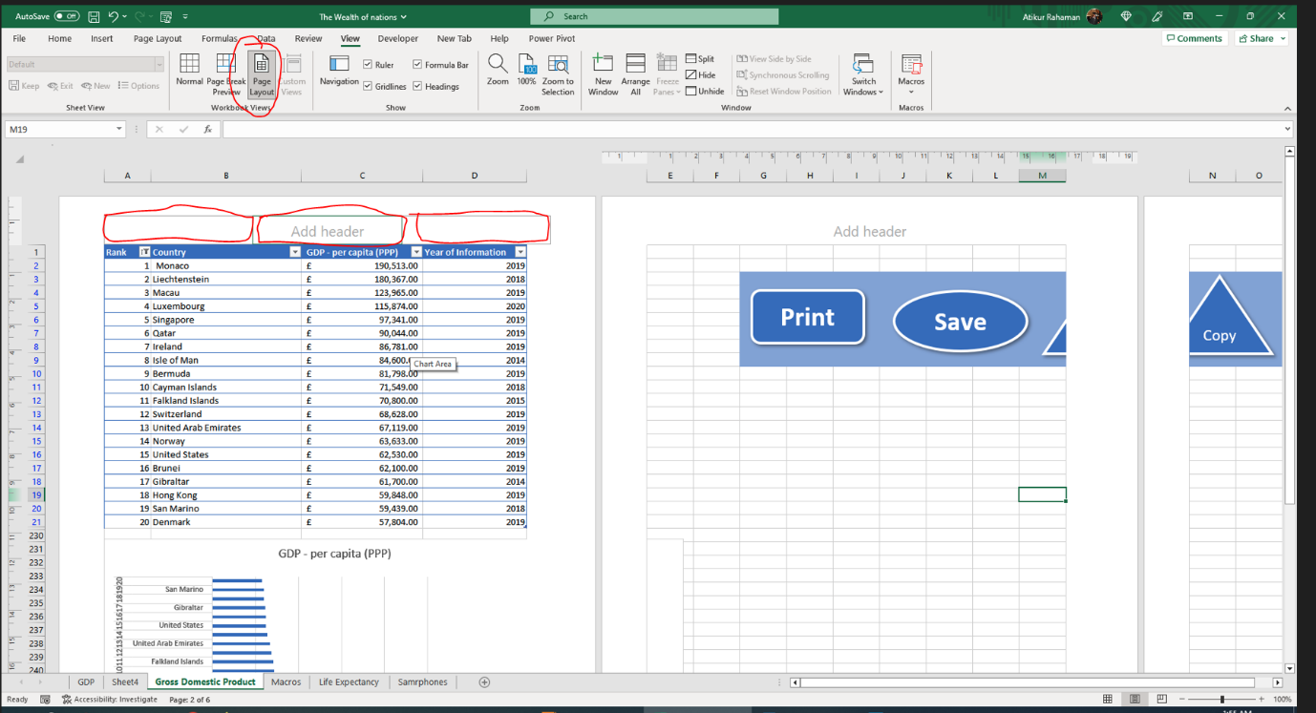

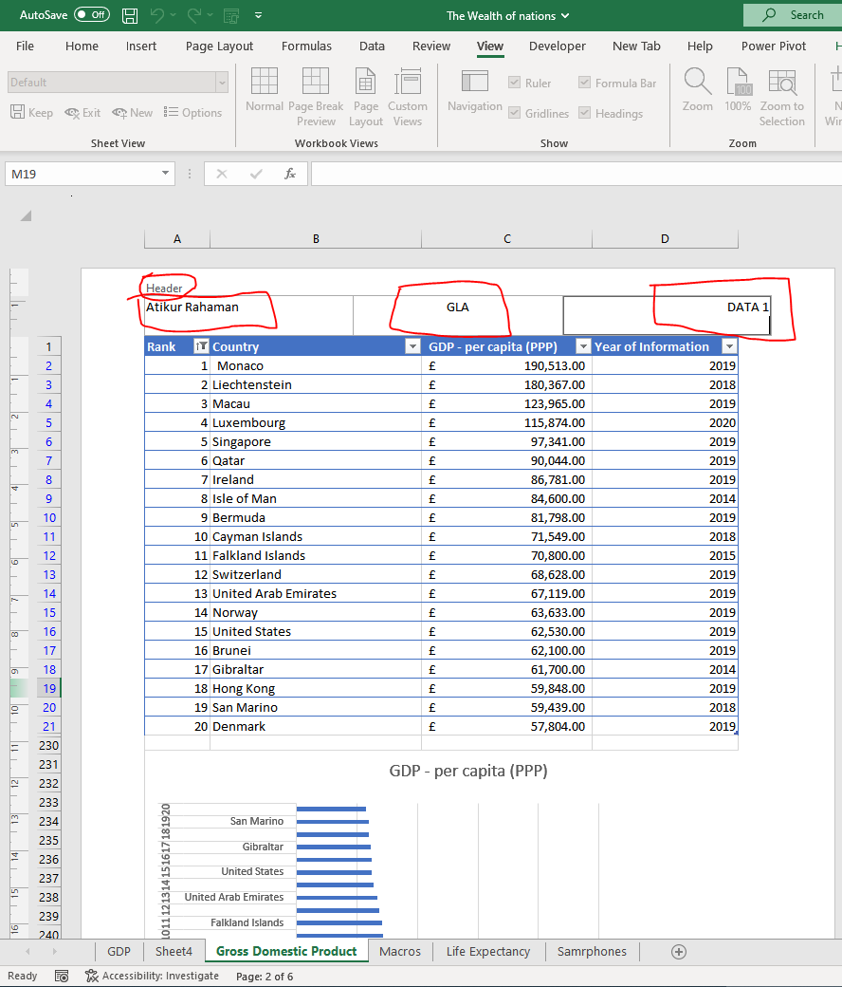

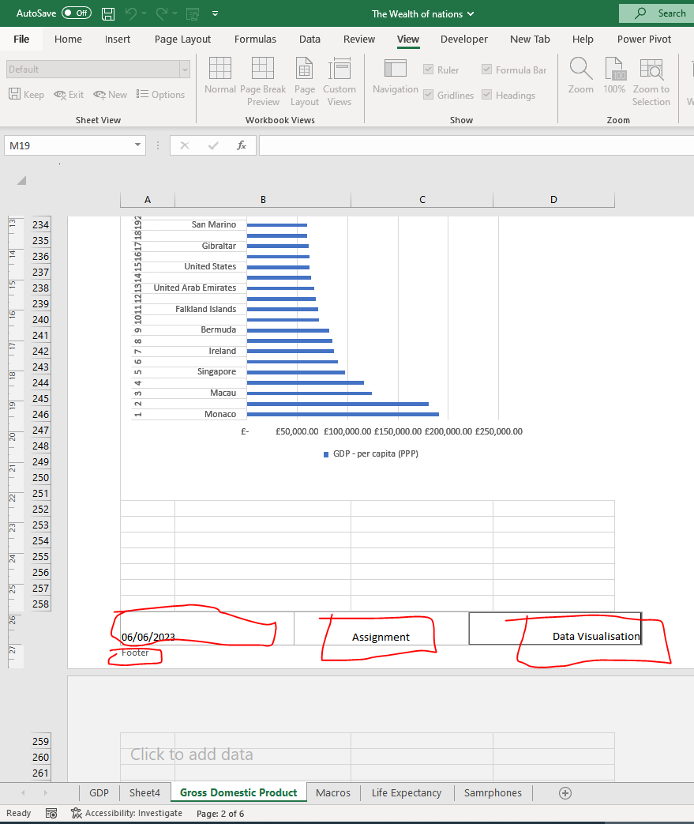

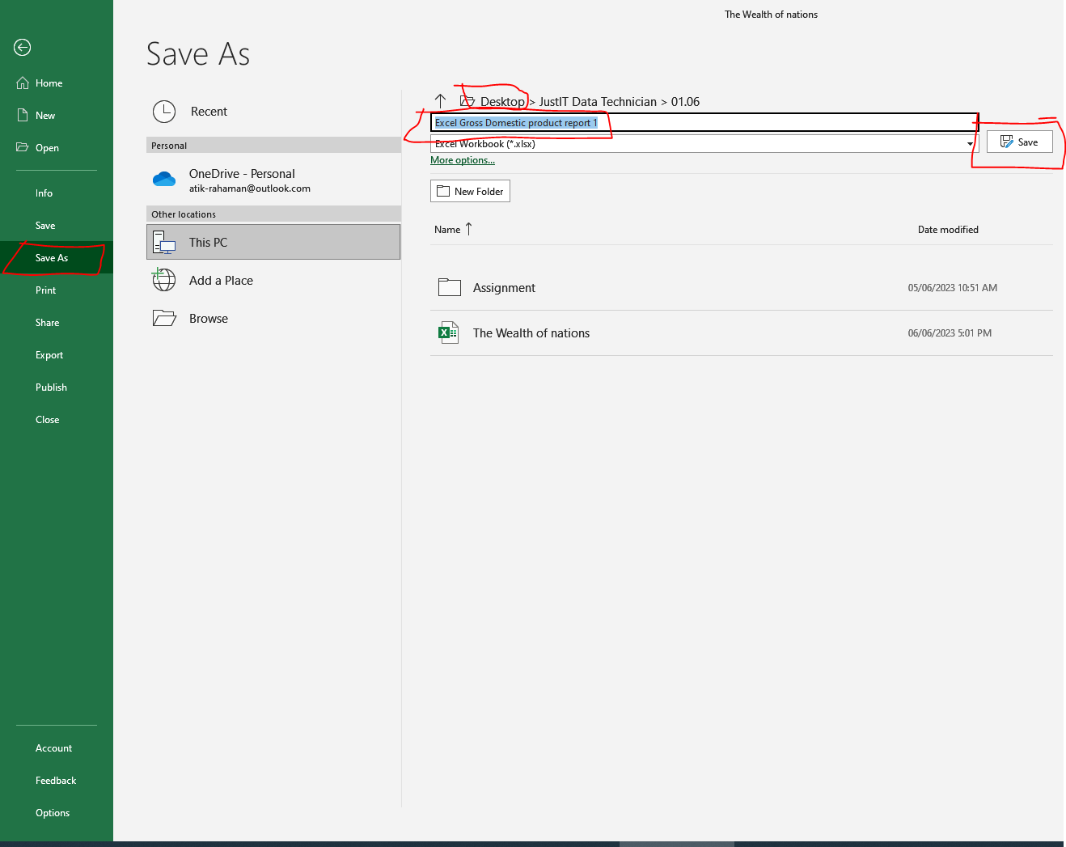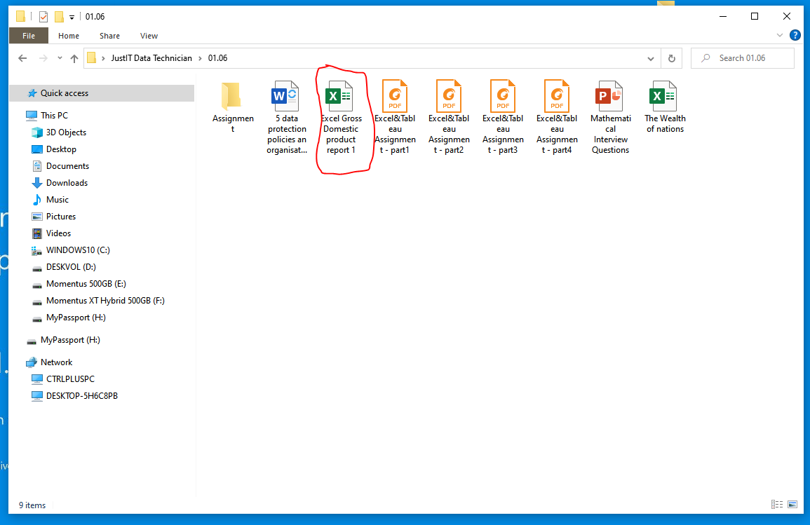

TABLEAU
- Import Data The Wealth of nations

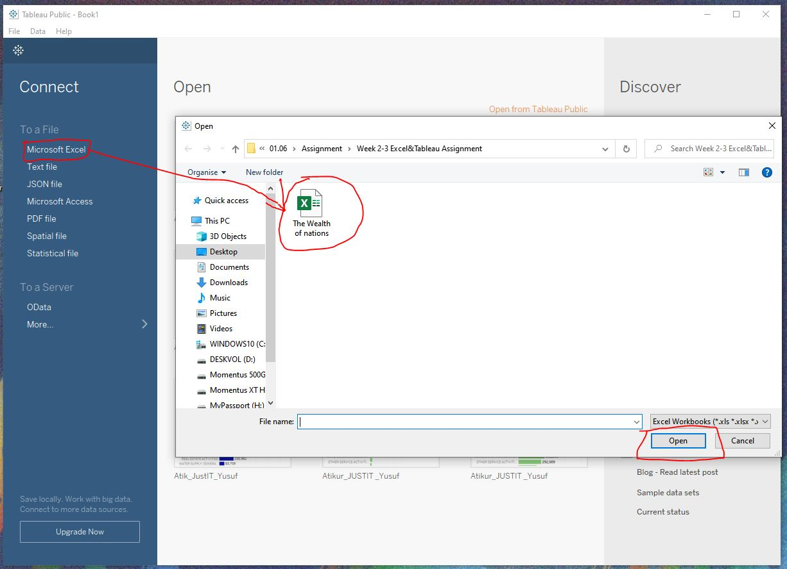

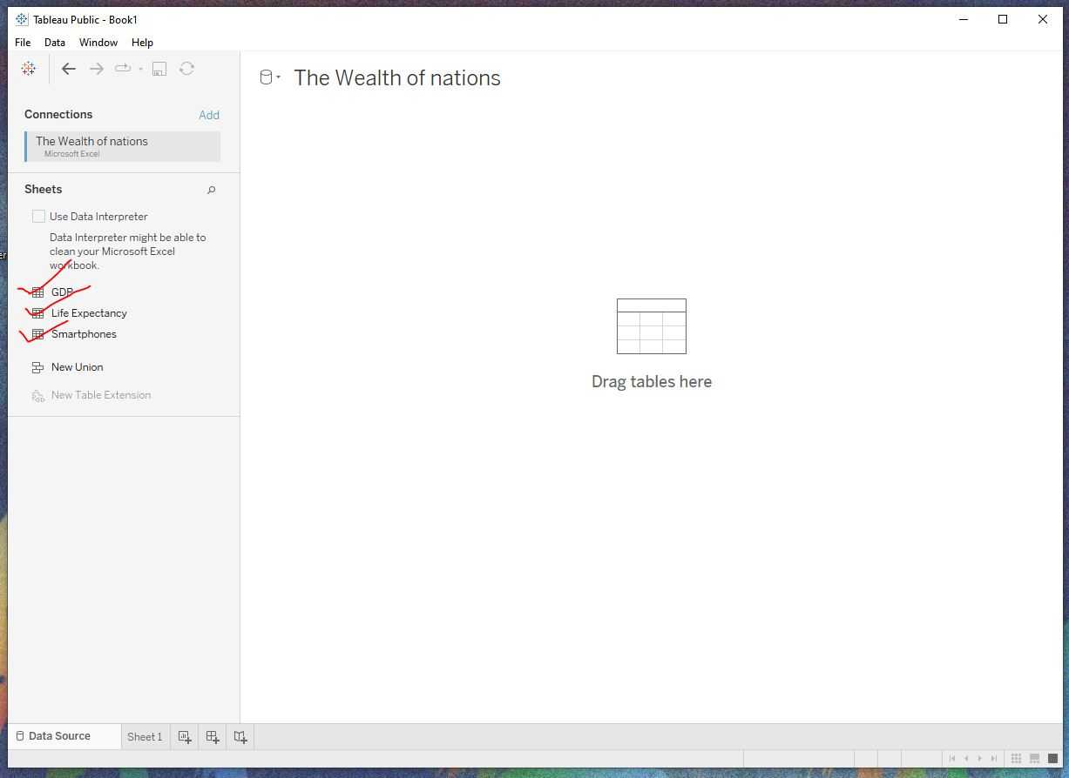

- Set relationships.

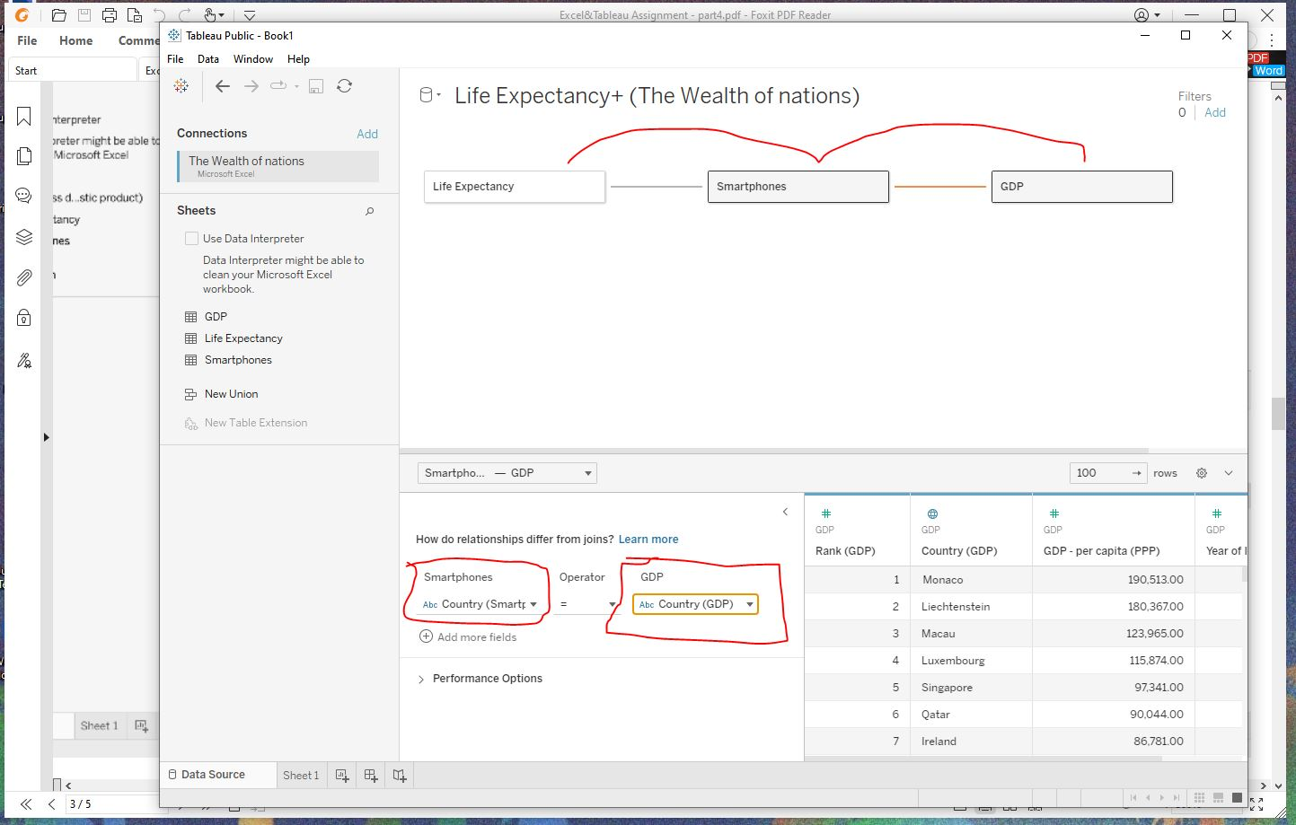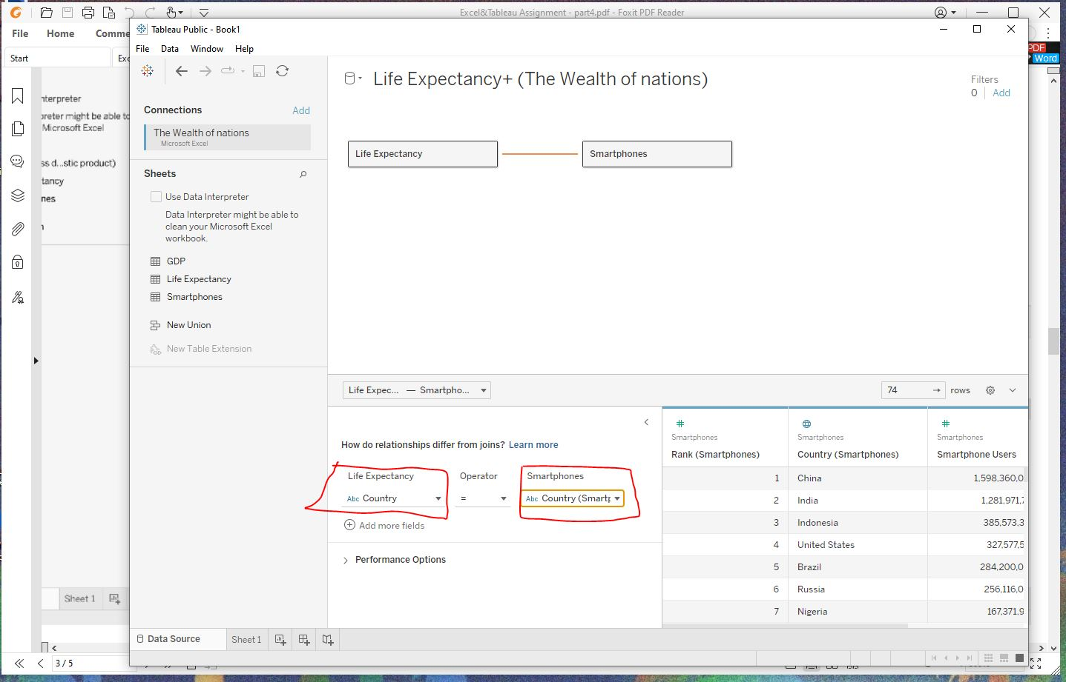

Rest of the completed tasks can be found by clicking the link below

https://public.tableau.com/app/profile/atikur.rahaman/viz/AtikurRahaman_JustIT_Assignment1_Yusuf/Dashboard?publish=yes

THE END

